LAB_2_EBS practice

To create an ECS instance follow the below stps

Visit the AWS management console and open EC2 Menu

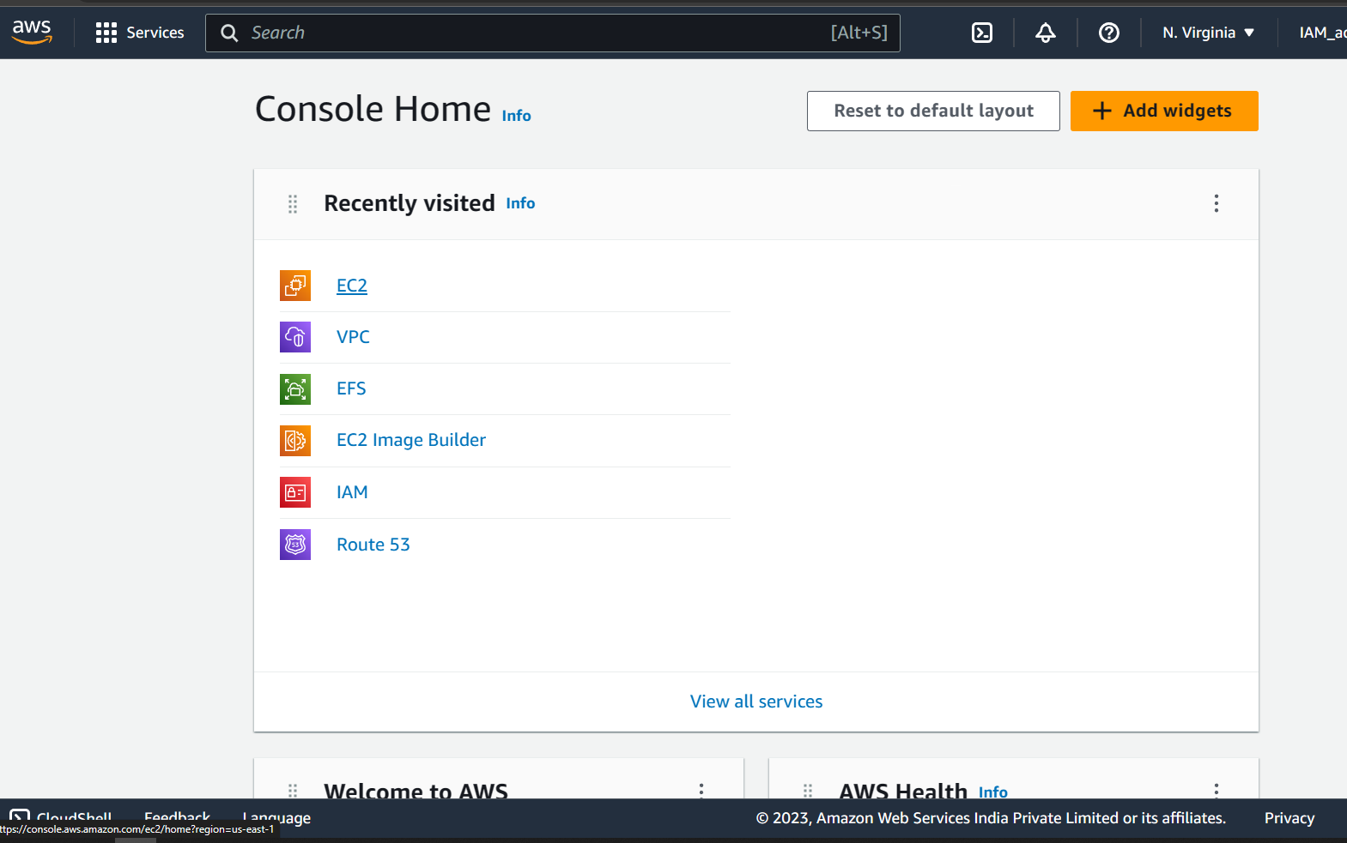

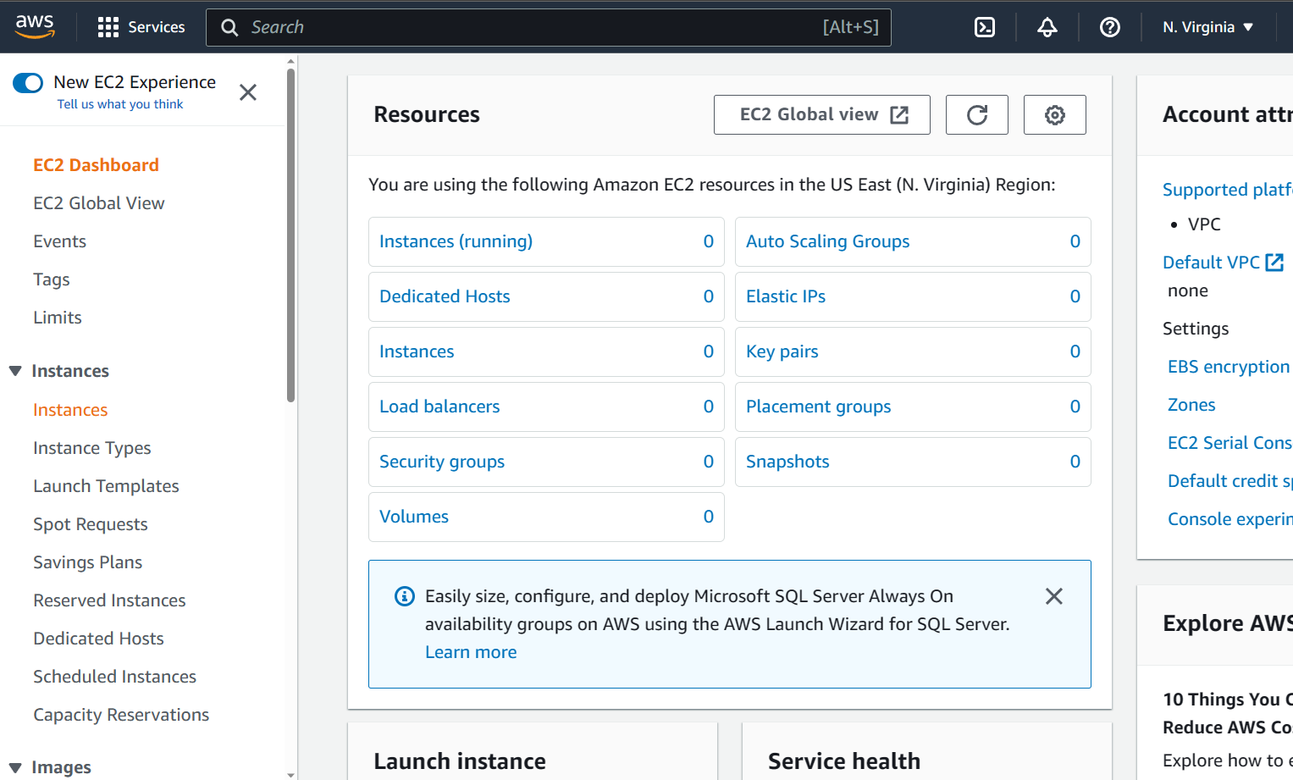

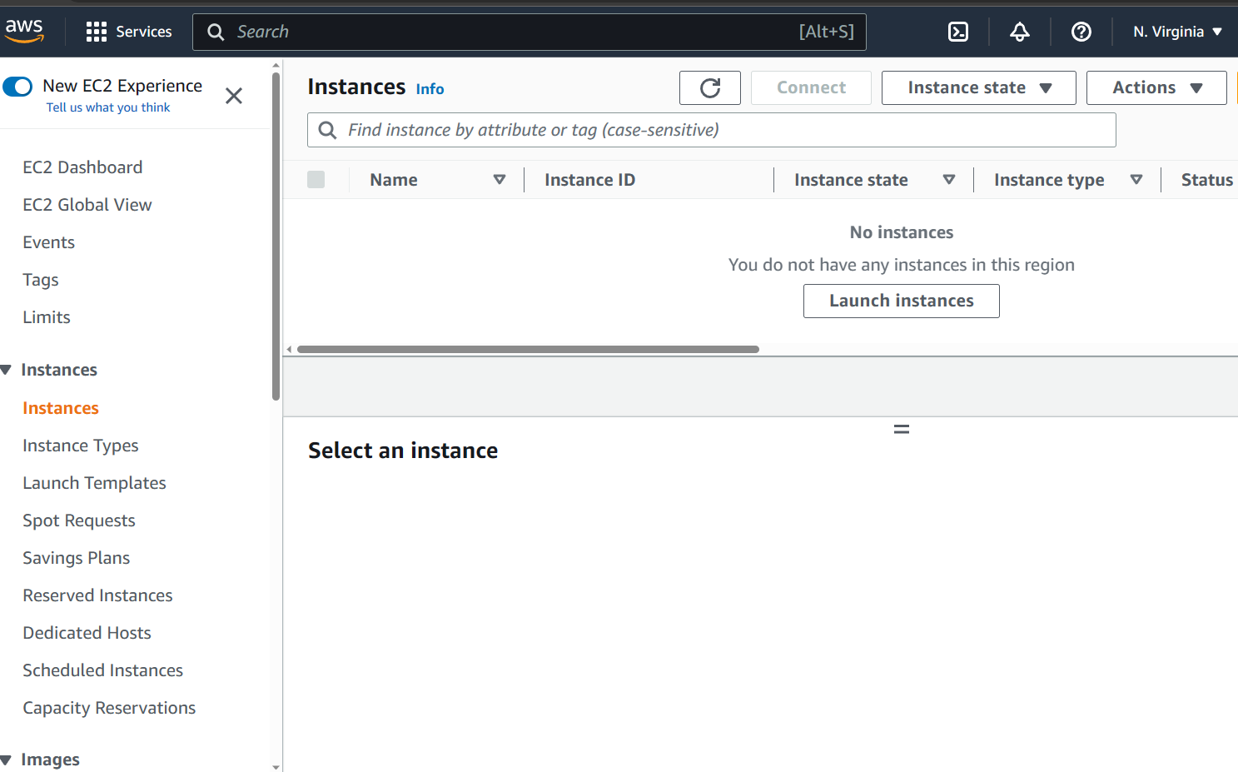

Click on the **instance** menu and click on **Launch instance** button.

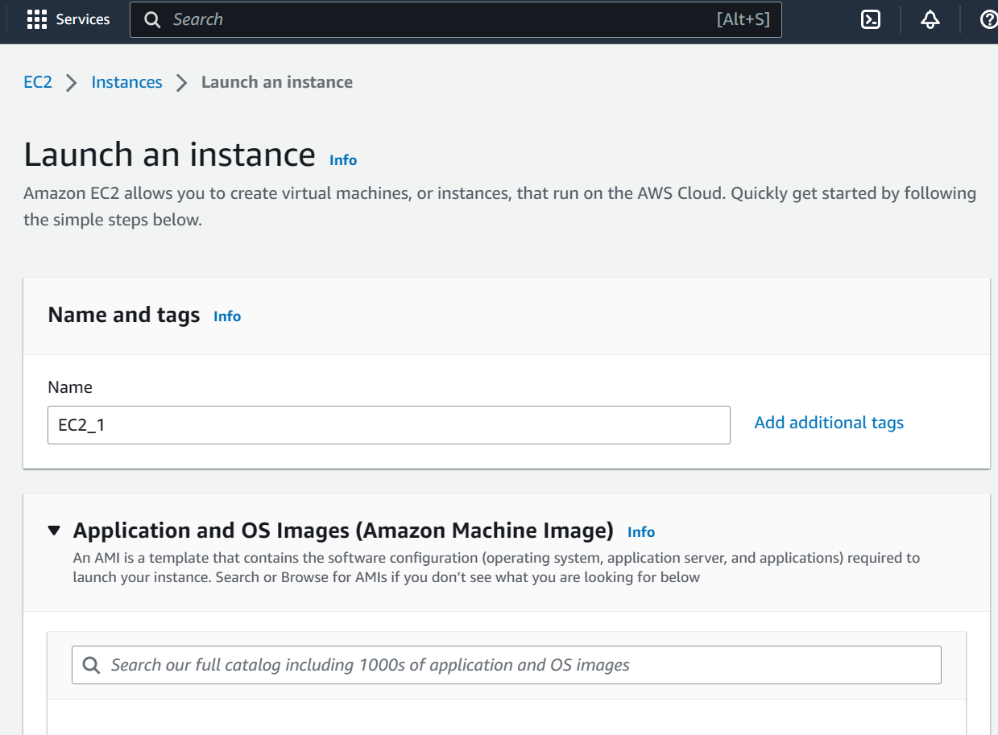

File a desired name and select **Ubuntu** image under quick start section

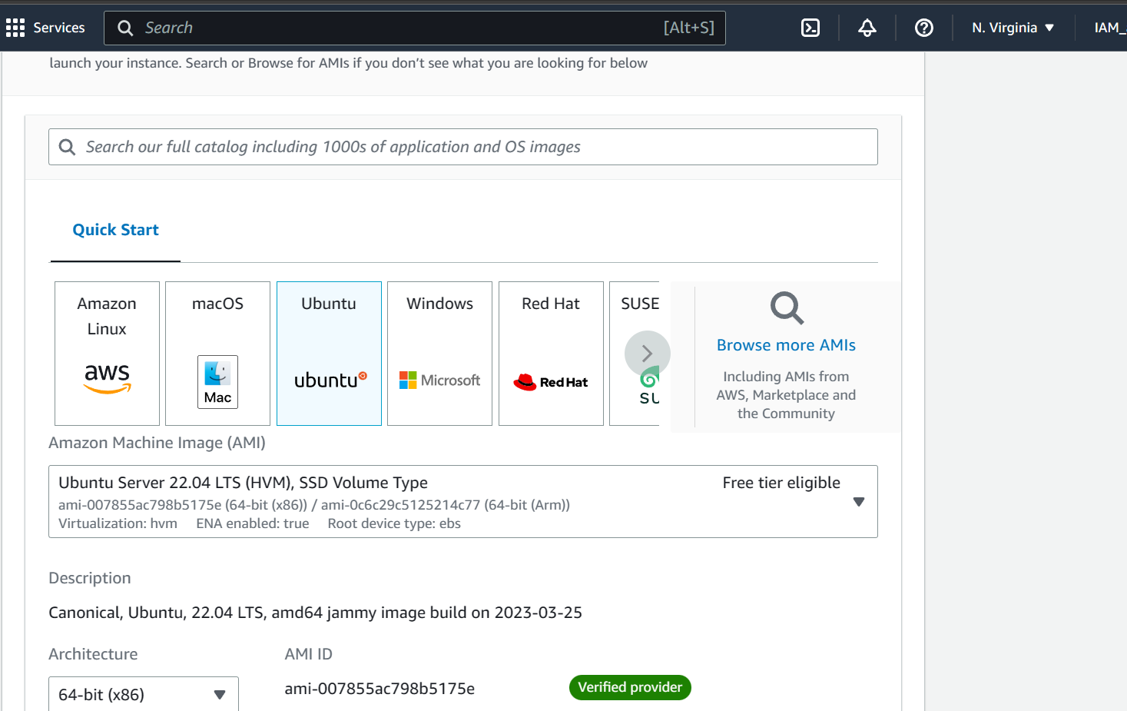

Under Network settings select click on **subnet** and select “us-ease-1a” as shown below

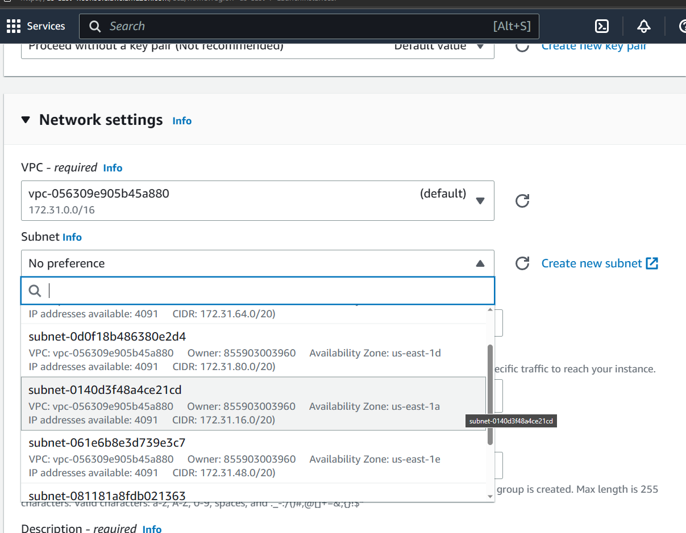

Under Key pair section selct “proceed without a keypair”

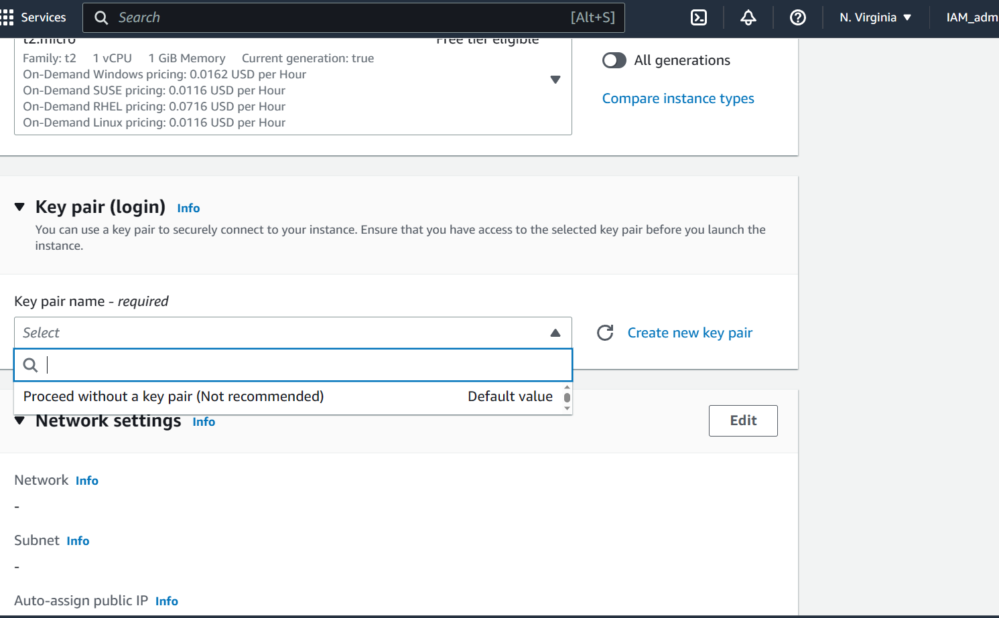

Check storage configuration

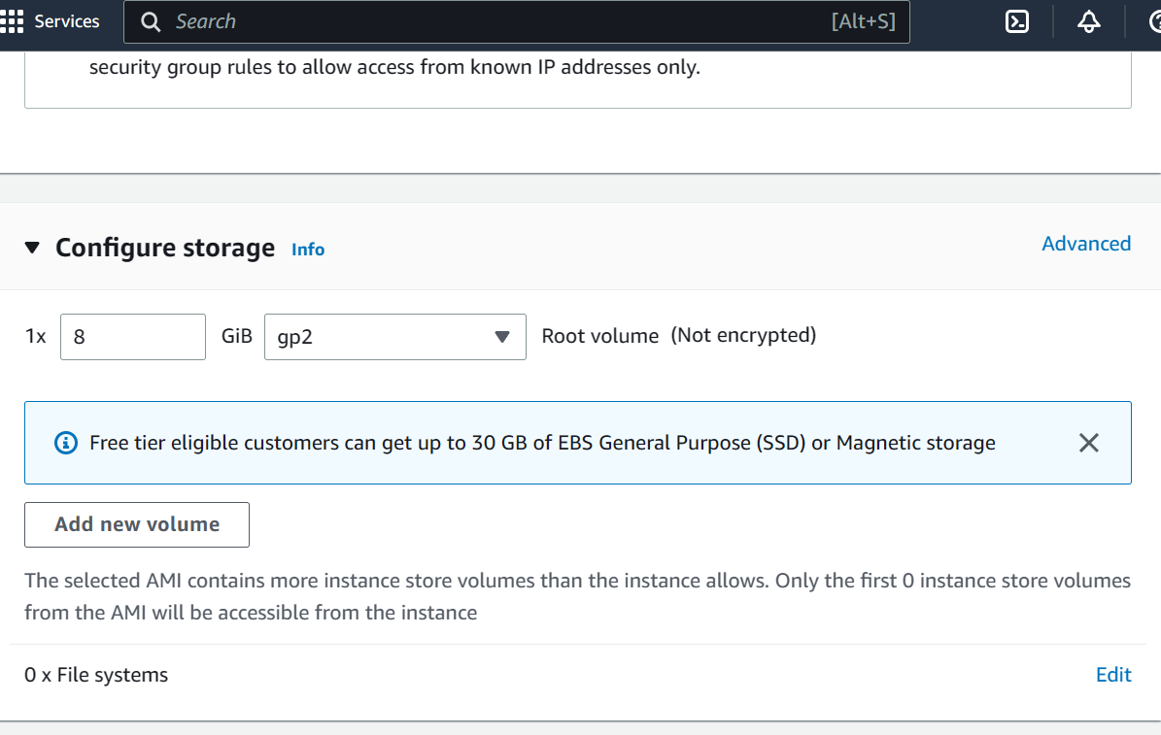

Scroll down and click on launch instance

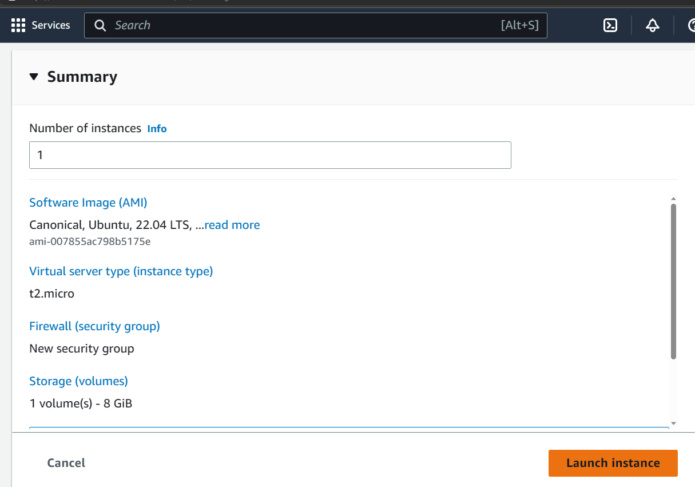

Congratulations you have successfully created an instance in Us-east-1a zone.

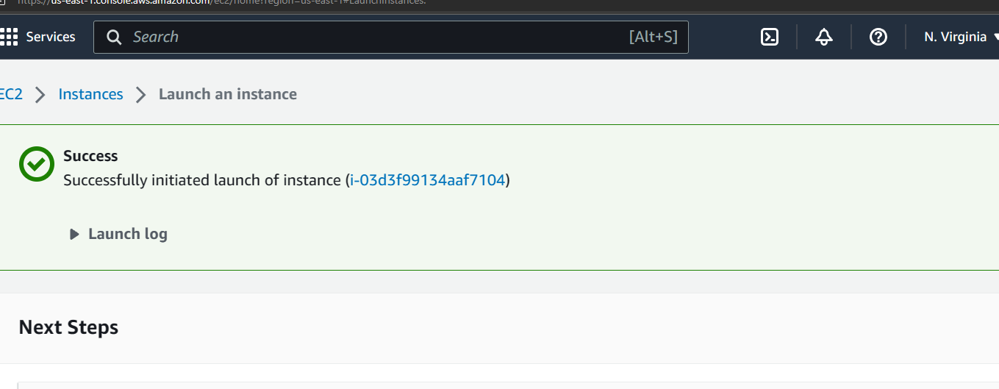

You can confirm the instance creation by visiting the Instance menu

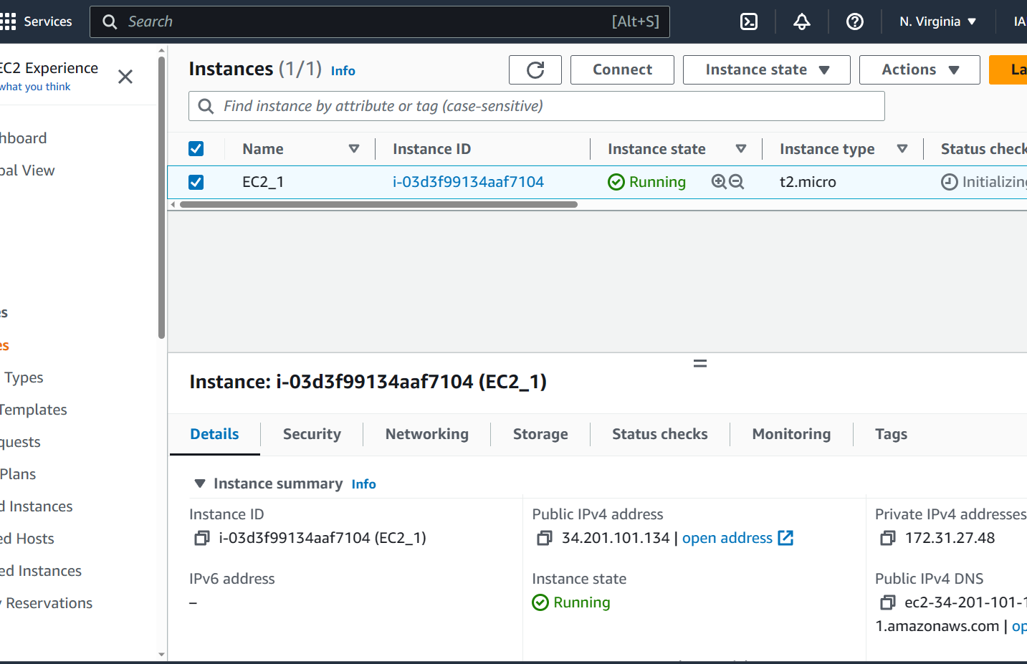

To create an EBS volume, scroll to the right and check the Availbility zone of the instance

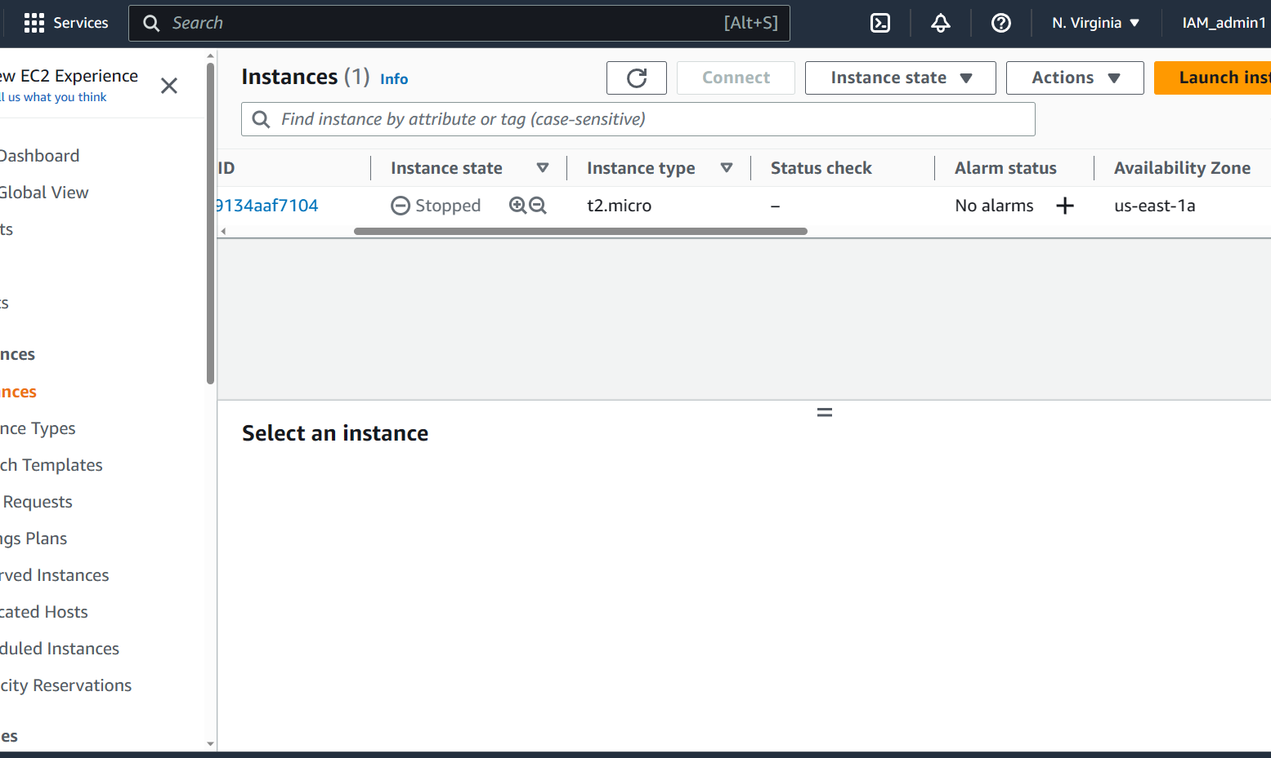

Click on **Volume** under Elastic block store section

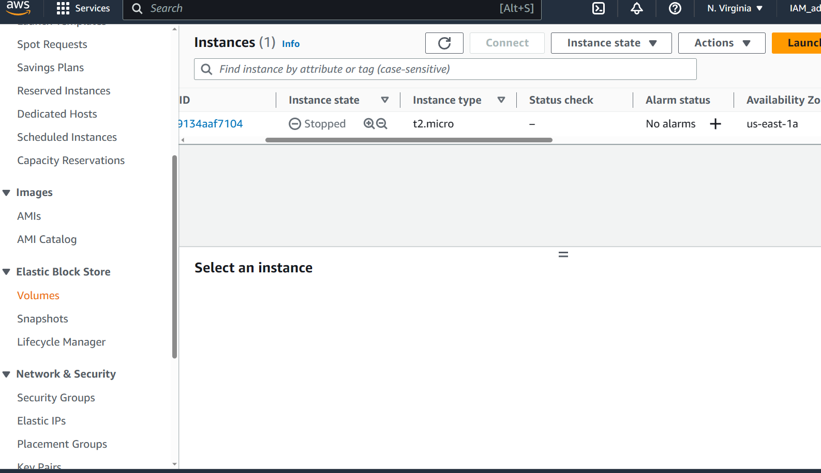

You will notice a volume already created which is associated with the instance created earlier.

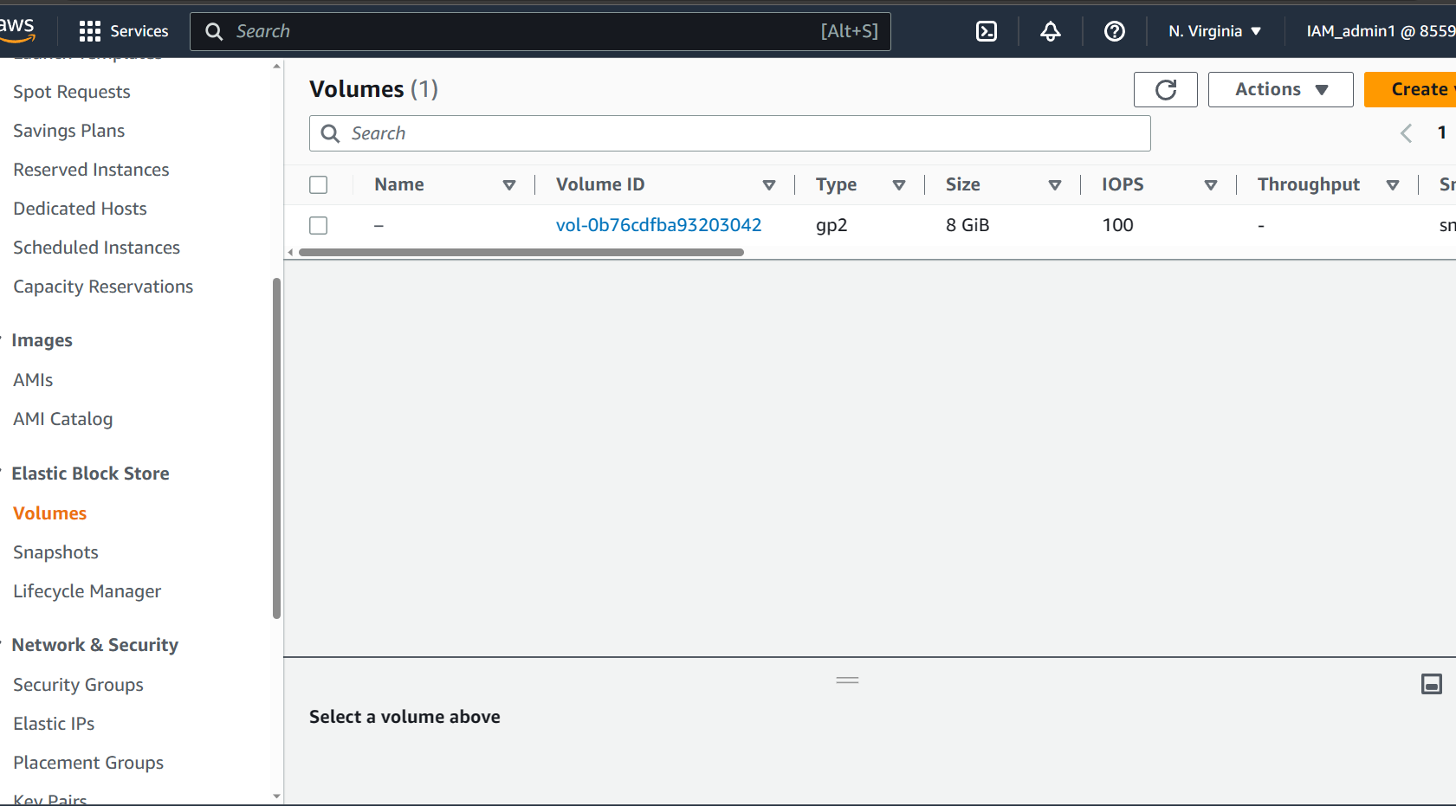

Click on create a volume and fill the size as 3 as shown below

Make sure to select the Availability zone in which the Instance was created earlier.

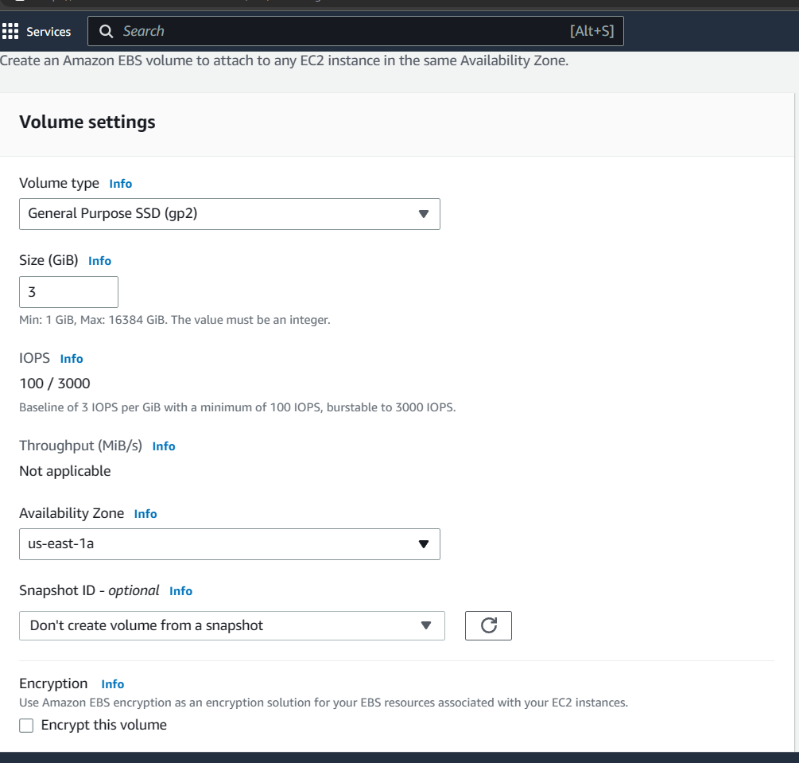

Scroll down and click on create volume

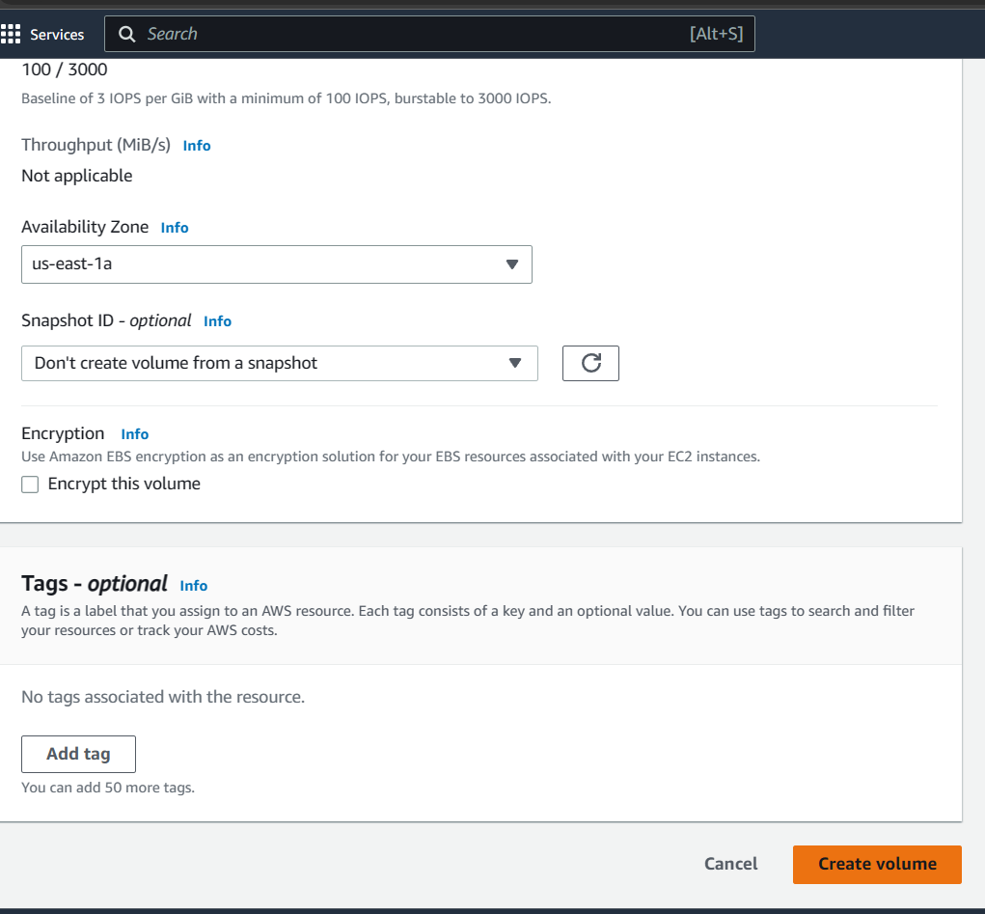

Congratulations you have successfully created a volume of 3gb in the save availability zone as the instance

You can confirm the same by checking the list of volumes recorded below

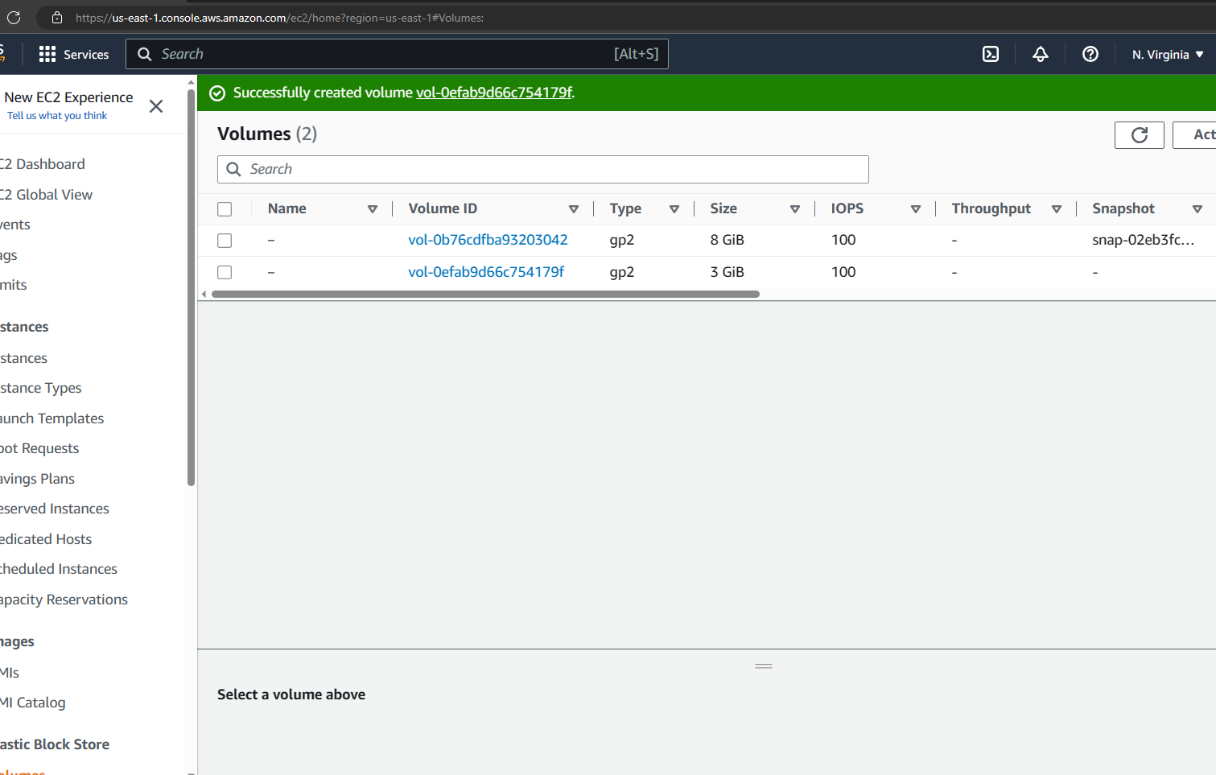

To attach the volume to the EC2 instance Select the newly created volume and click on actions button and select **Attach volume** menu

Note: make sure the instance that you intend to attach is active and running state

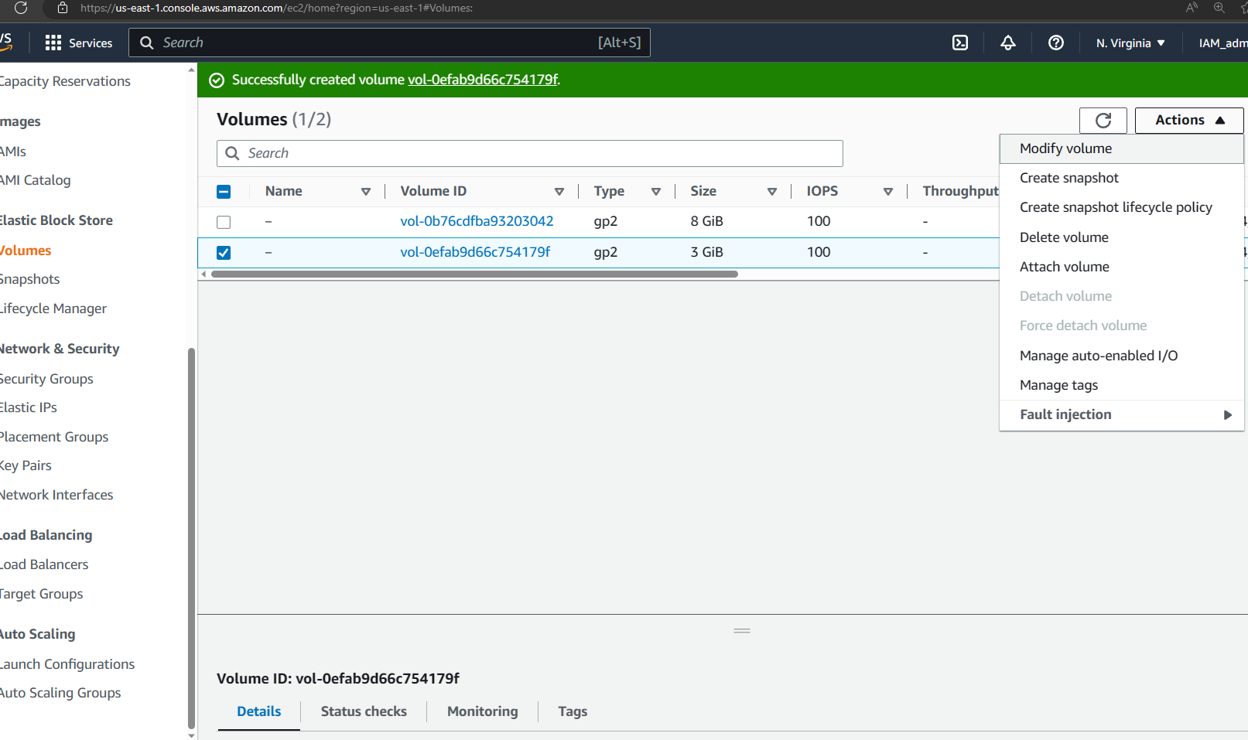

In the Attach Volume page click on the Instance Drop drown menue and select the instance that was created earlier as shown below

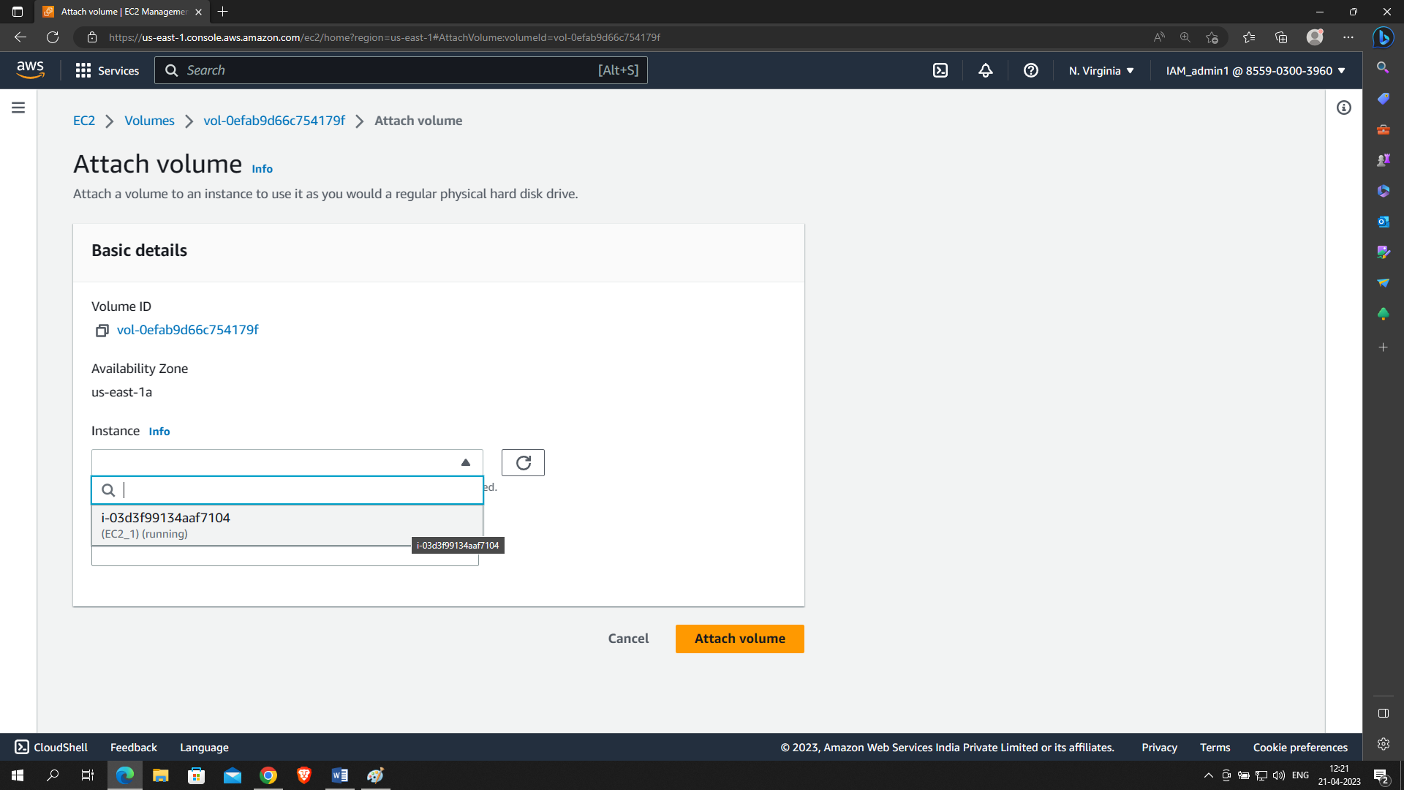

After selecting the instance click on **Attach volume** button at the button right

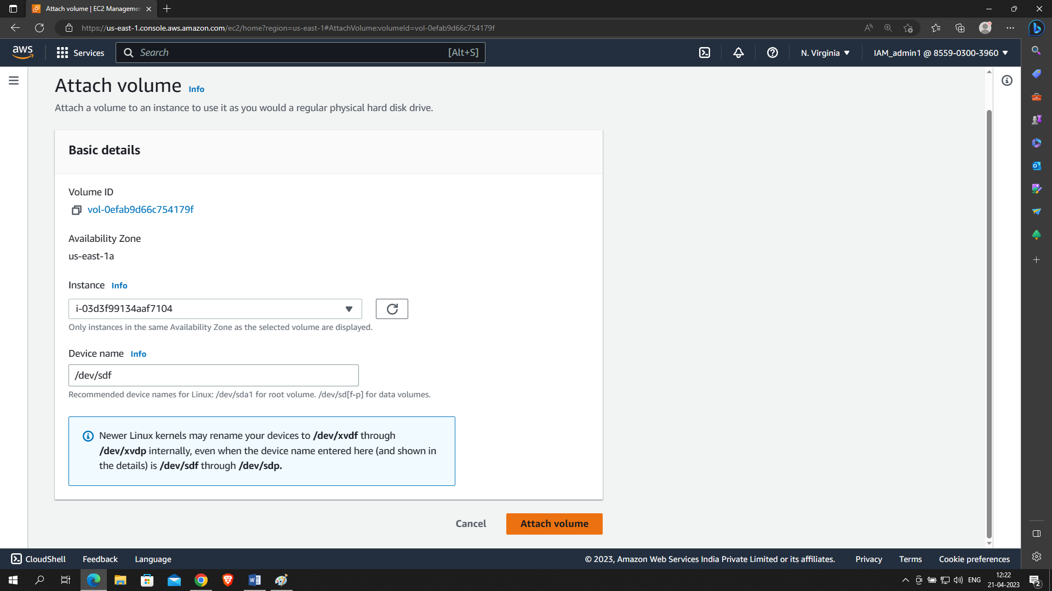

Congratulations you have successfully attached the volume to the instance

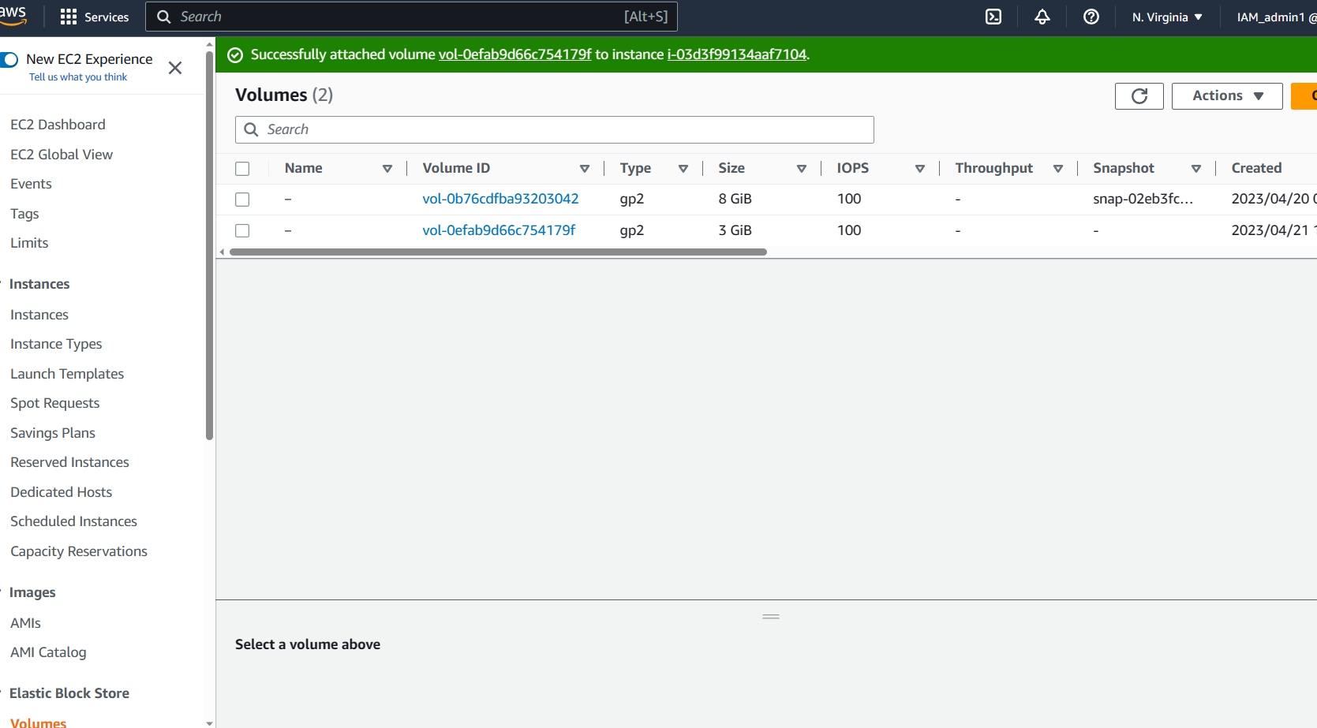

You can confirm the use of the volume by scrolling to the right of the volumes menu and reading the Volume state collume

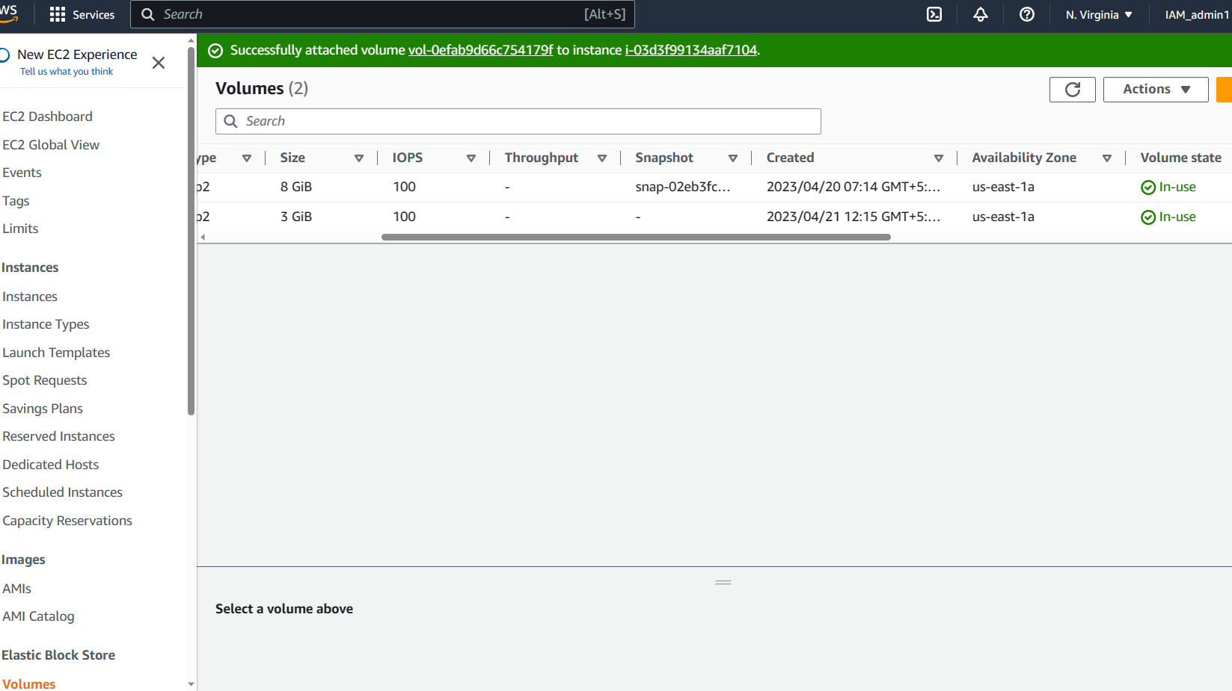

To create a snapshot of the volume, select the volume and click on the actions button and select **Create snapshot** option as shown below

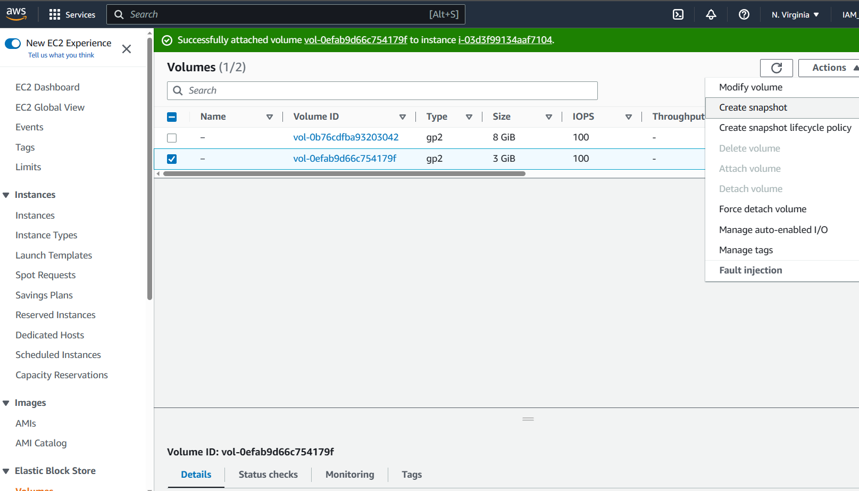

Specify a description and click on create a snapshot button

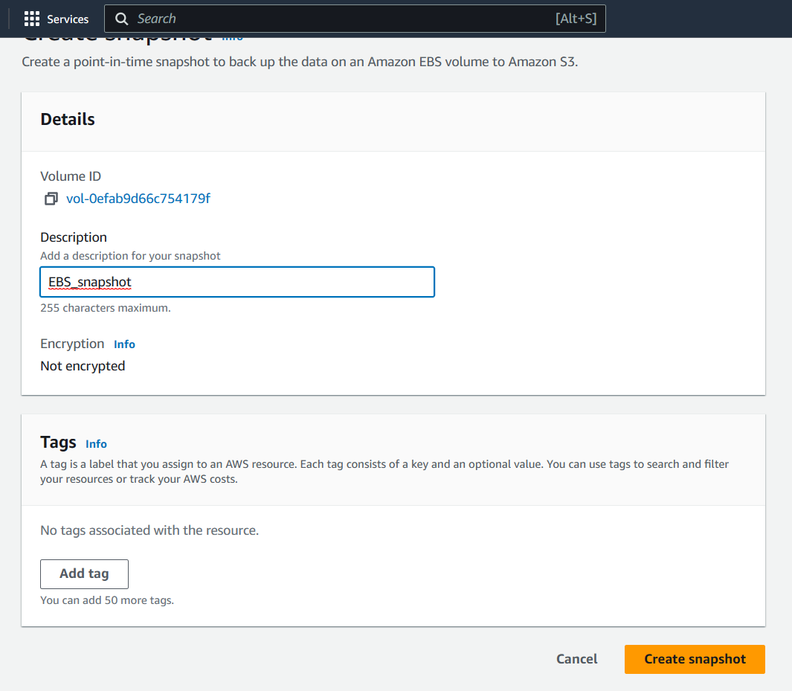

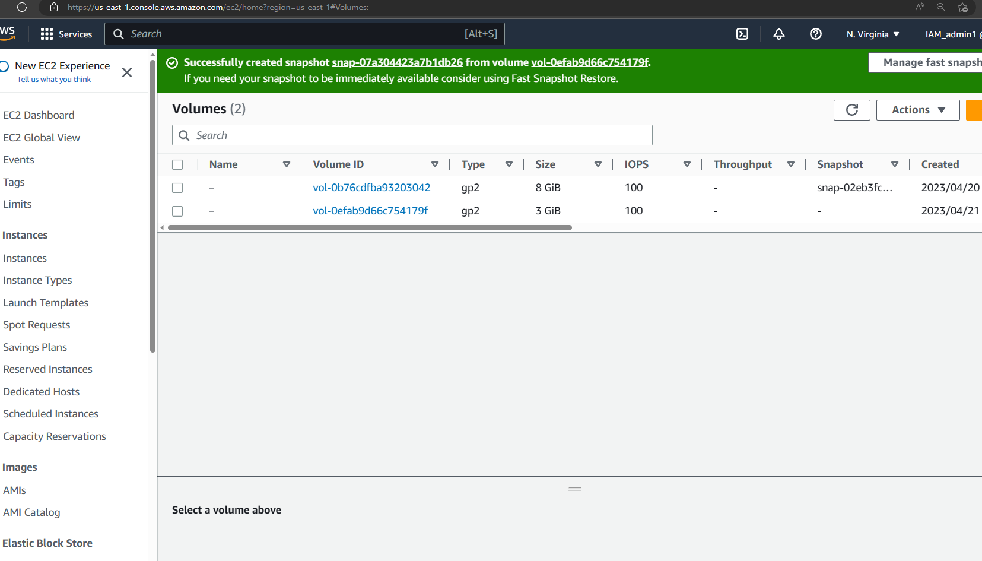

You can visit the snapshot section under **Elastic Blcok Store** section and confirm the creation of the snap shot

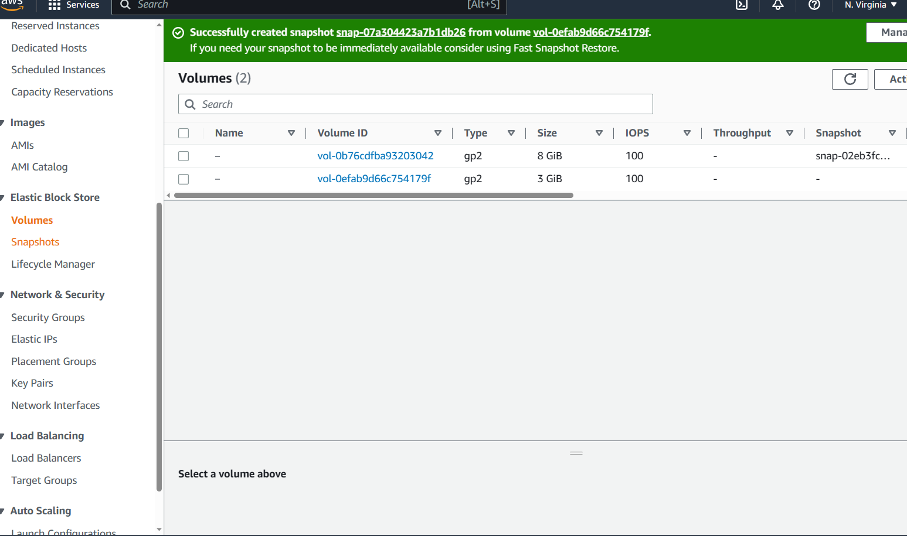

You will find a newly created snapshot of the volume as shown below

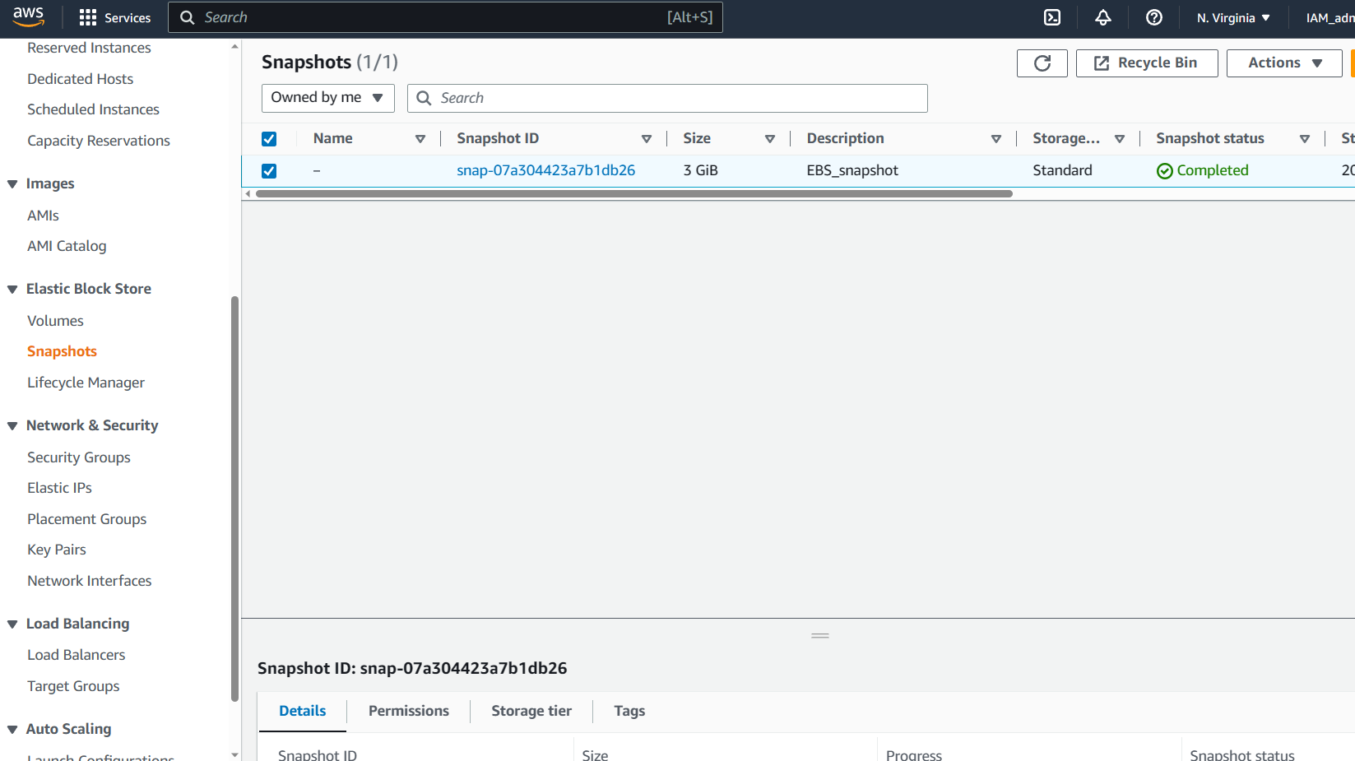

Create an instance in a different Viability zone by visiting the Instance menu and clicking on **Launch an instance** button as shown below

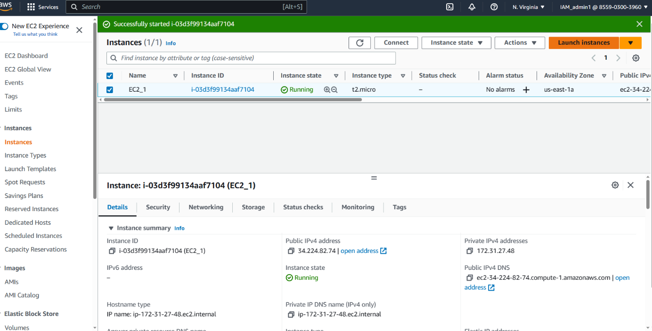

Specify a name in the Name field and select Ubuntu in the quick start section shown below

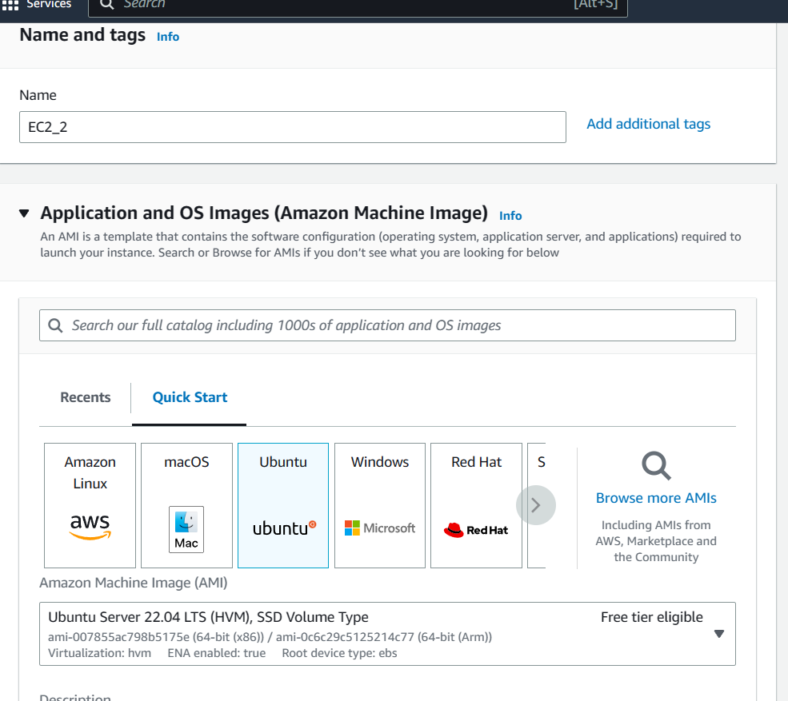

Under Keypair section select **“proceed without a key pair”**  as shown below

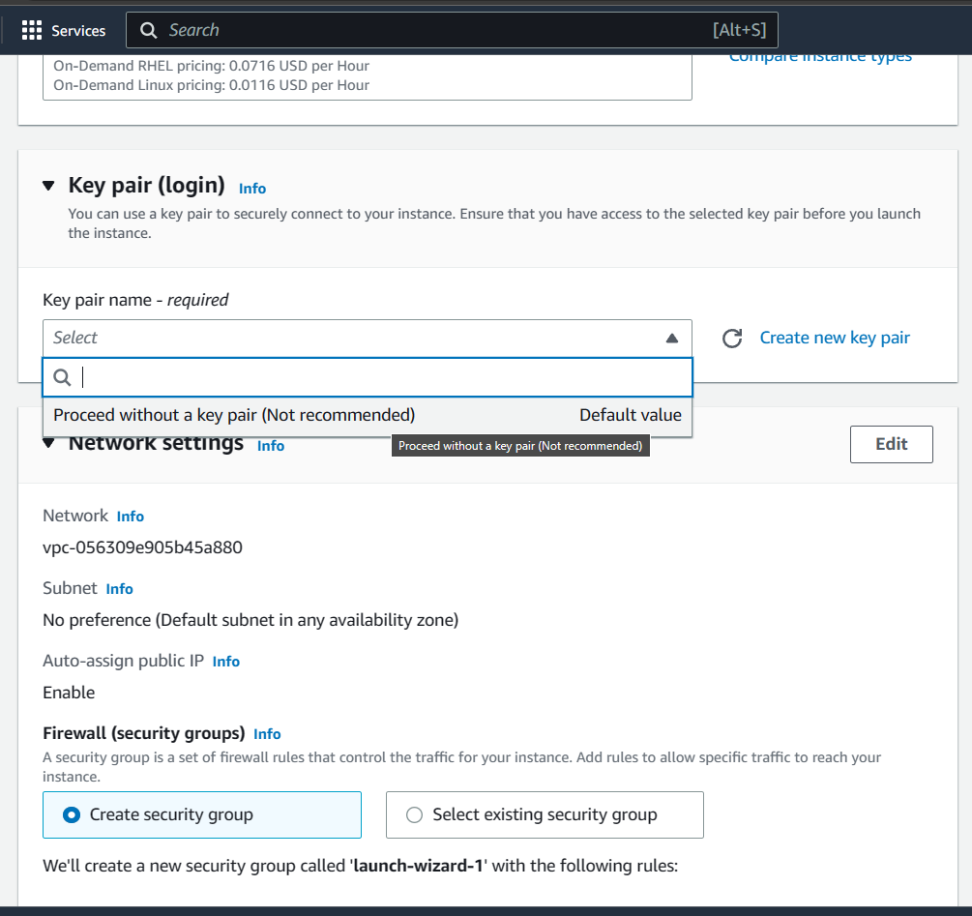

Under **Network Settings** click on **edit** and select the subnet as us-east-1b as shown below

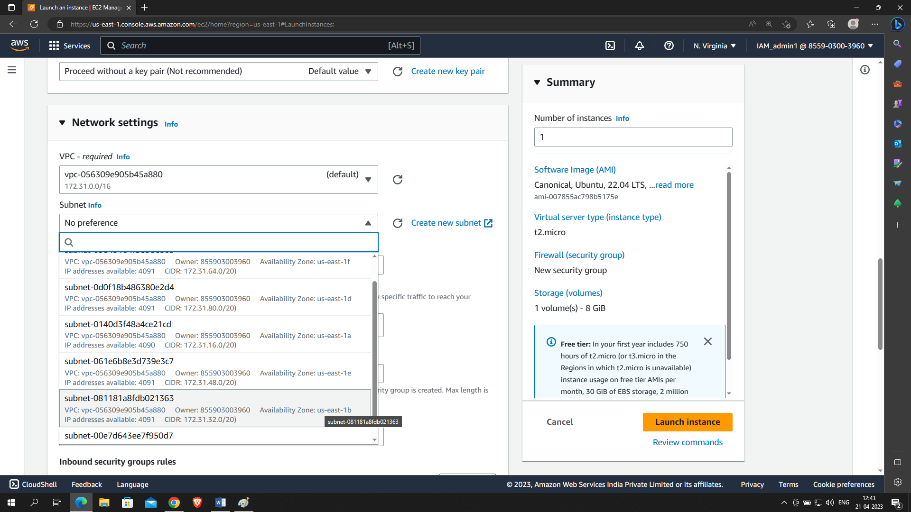

Scroll down and click on launch instance

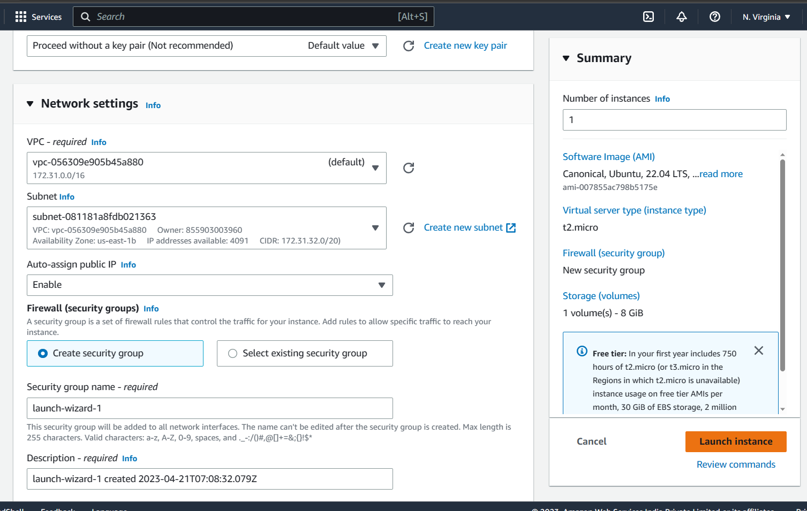

Congratulations you have created an instance in a different Availbility zone i.e us-east-1b

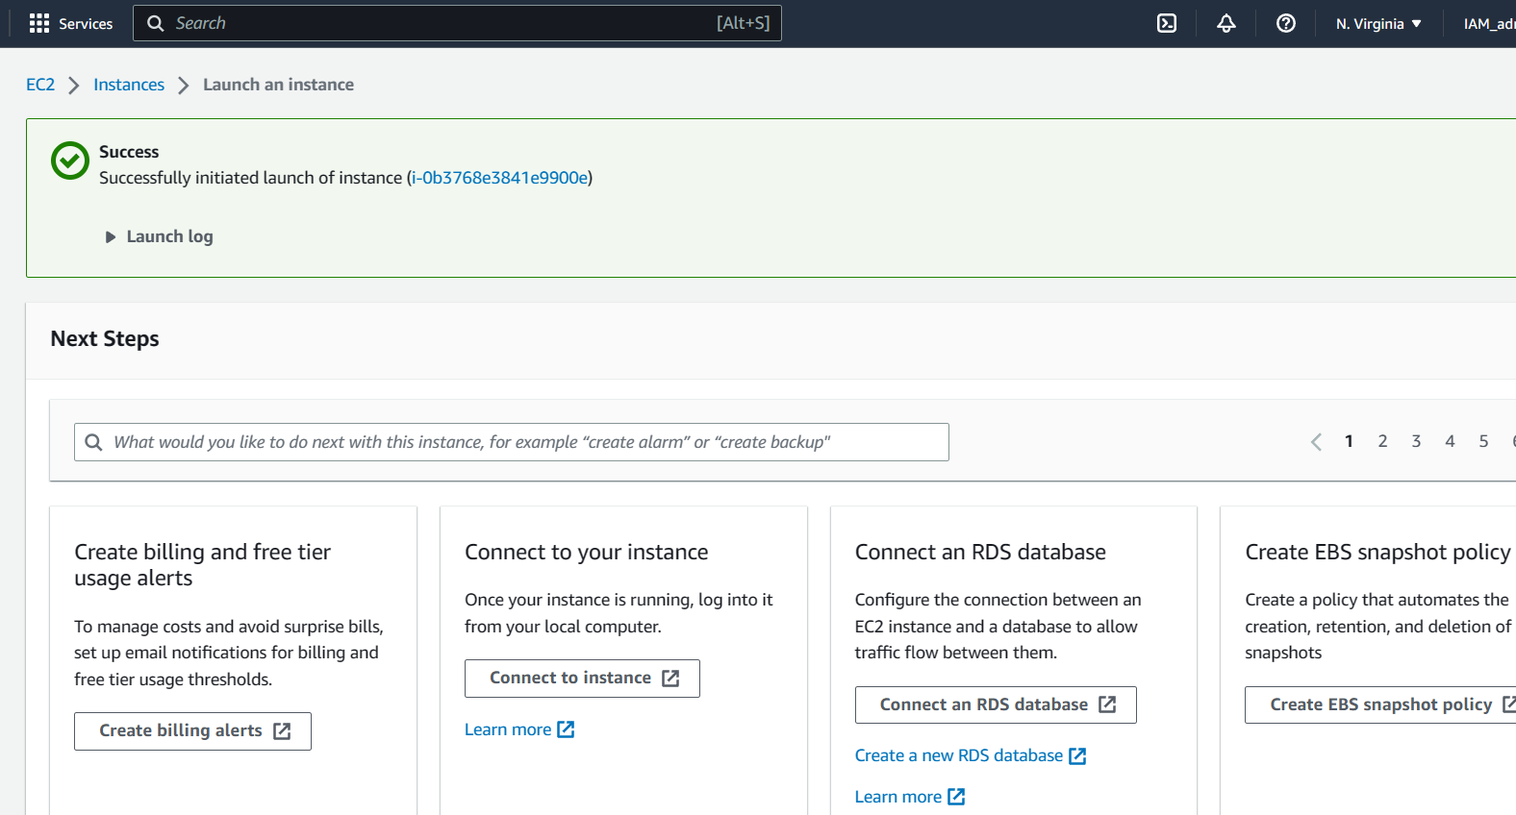

You can confirm the same by visiting the instance menu

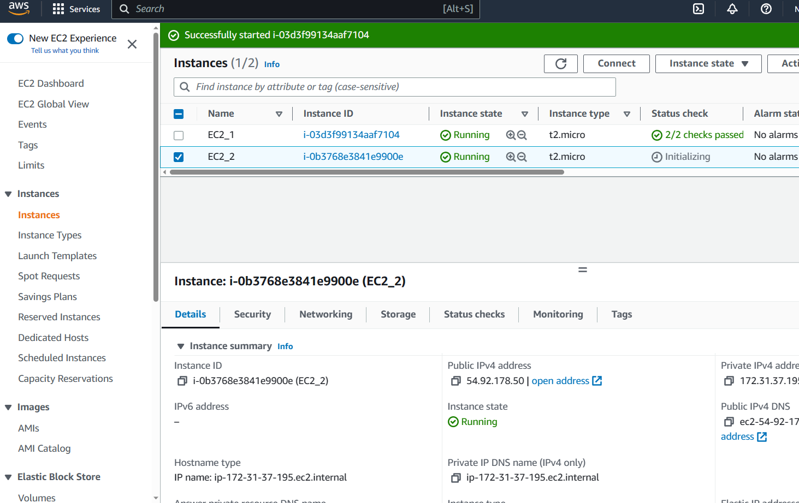

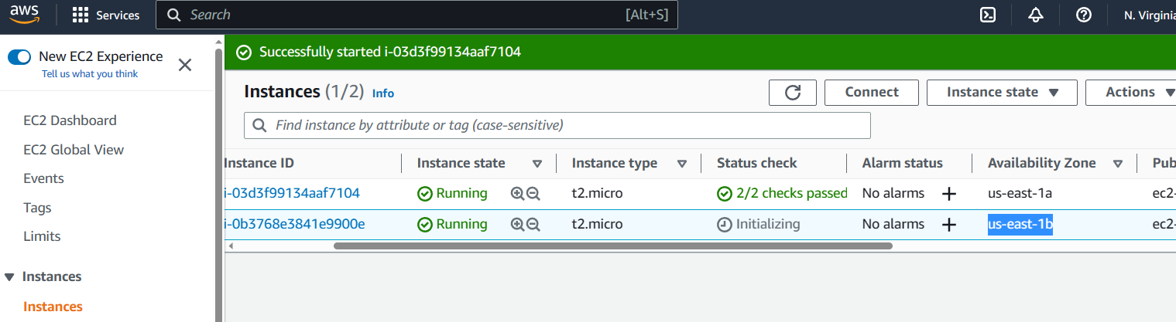

Visit the snapshot menu under **Elastic Blcok Store**  section

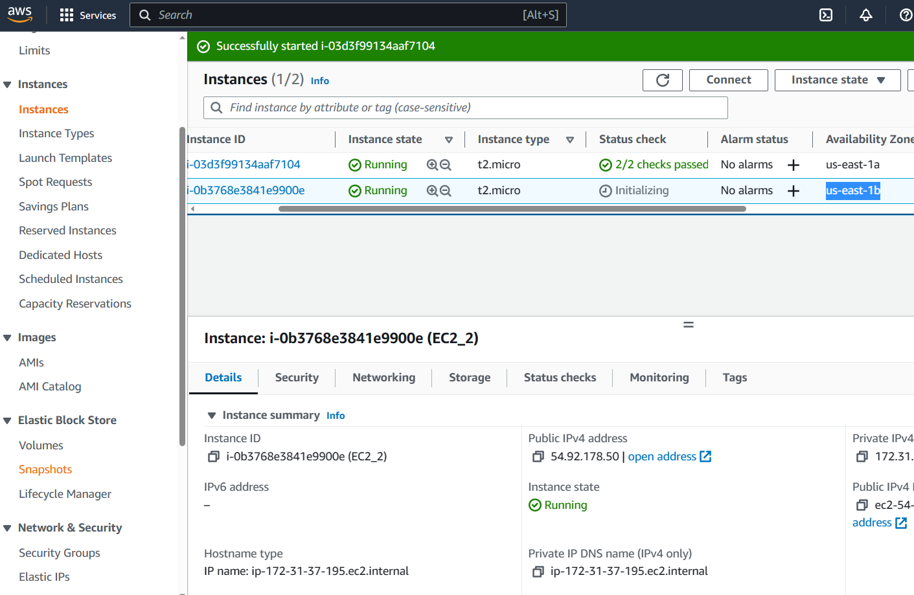

Select the previously created snapshot and click on actions button and select **create a volume from snapshot** as shown below

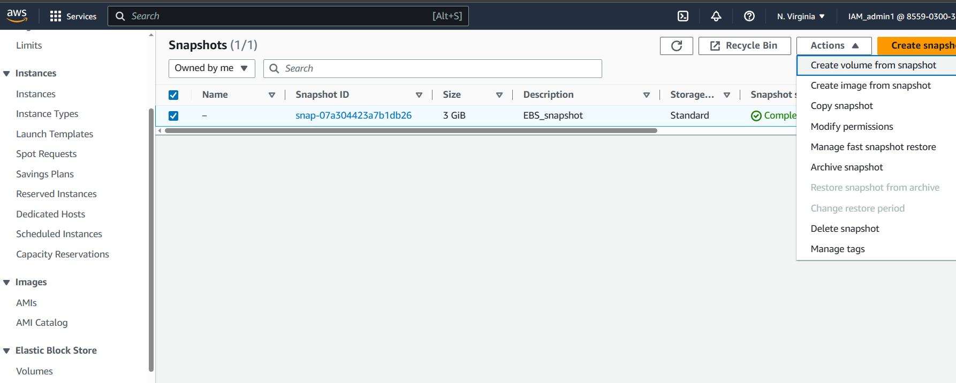

In the create volume page make sure to select the Availility zone similar to the availability zone set in the second instance

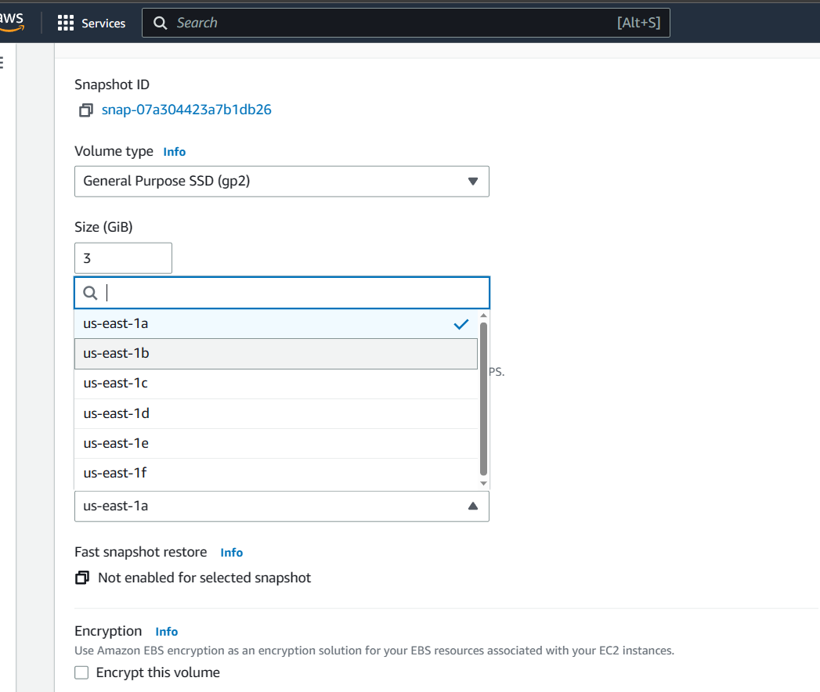

Scroll down and click on create volume

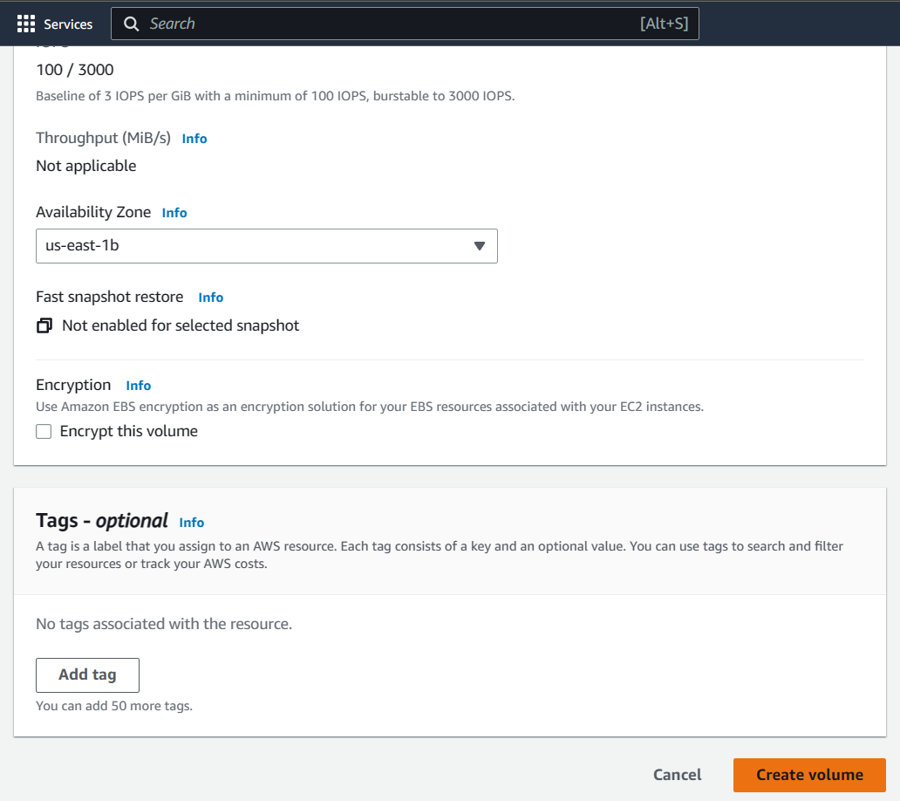

You can confirm the new volume creation by visiting the volume menu and identifying a new volume in available state with Availability zone similar to the second instance’s availability zone

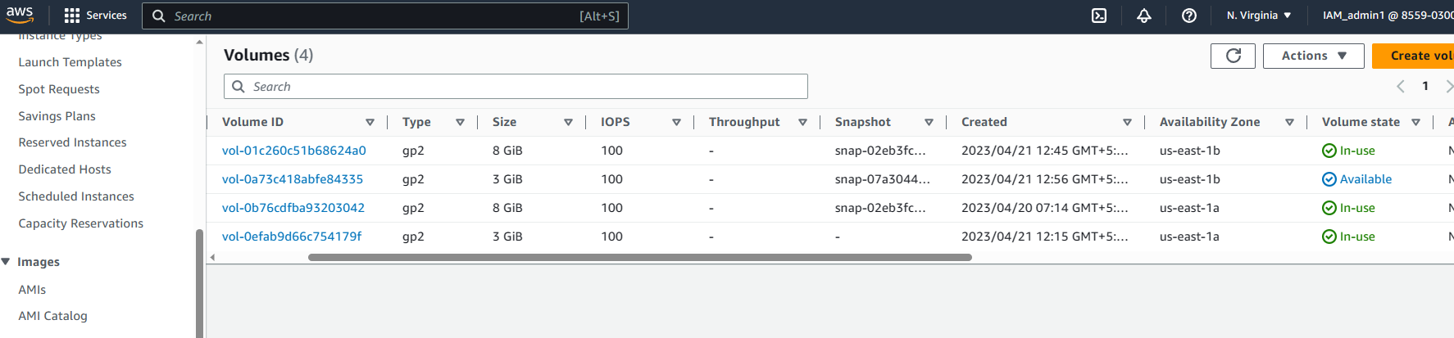

Select the newly created instance and click on actions button

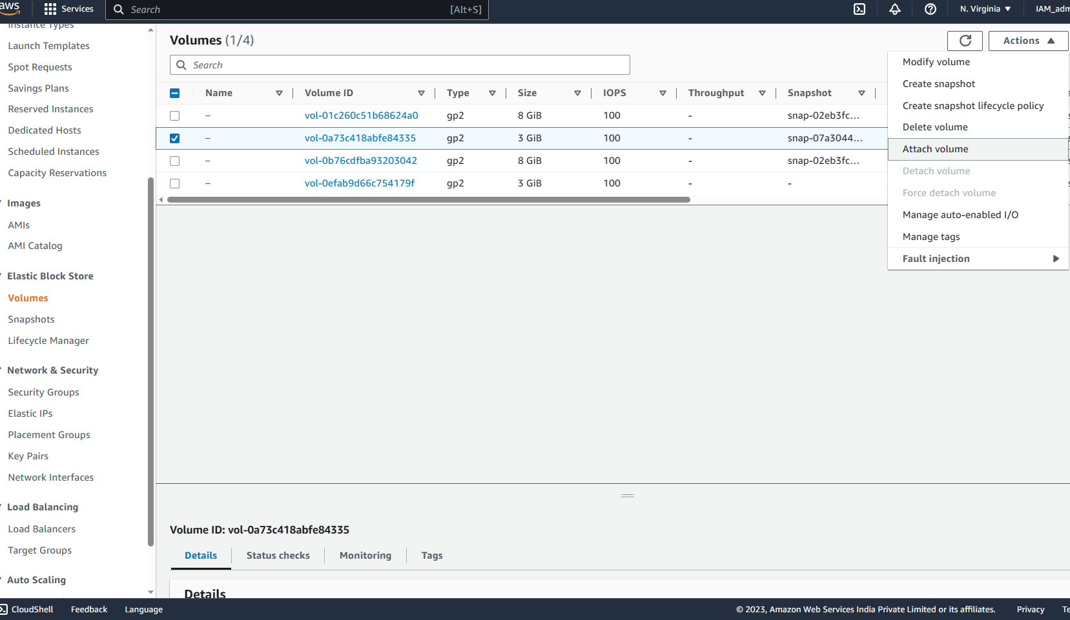

Click on attach volume

In the attach volume page select the recently created second instance i.e EC2_2 and click on attach volume button at the bottom right as shown below

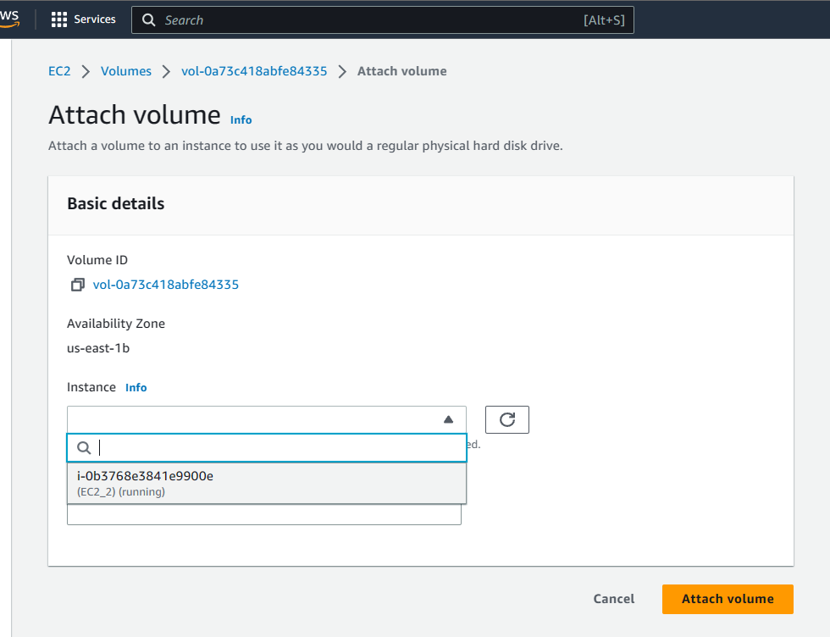

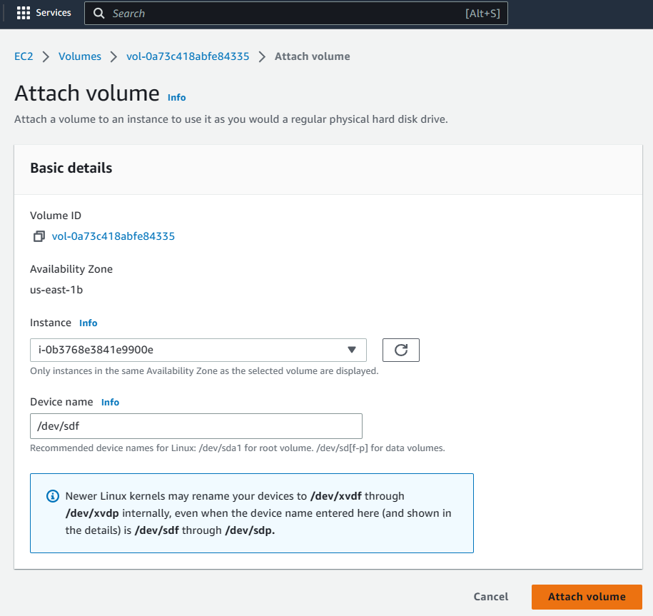

Congratulations you have successfully attached the volume to the second instance created in a different availability zone

Clean up

Visit the instance menu , select all the instances , click on **Actions** button and select **terminate instance**

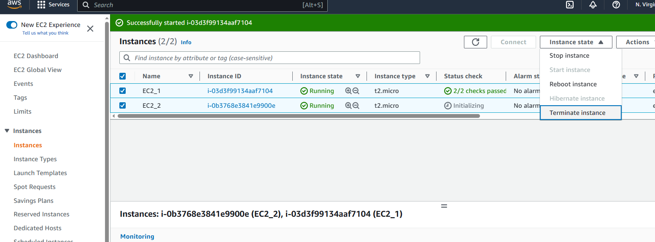

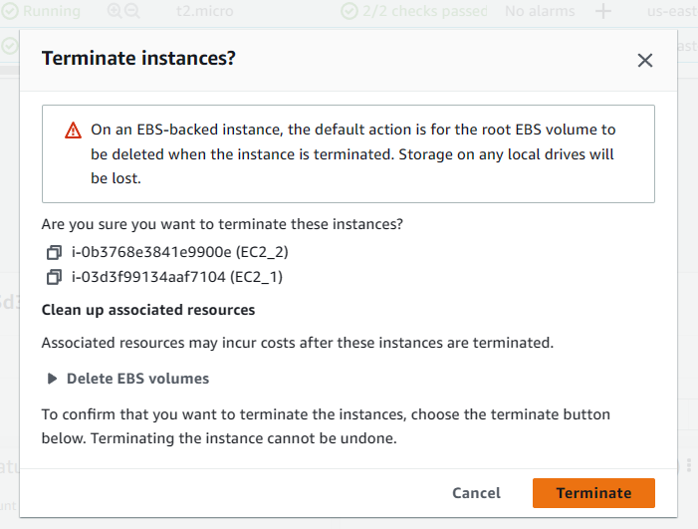

Click on terminate on the above pop up window

Visit the volume section under **Elastic Blcok Store** , select all the volumes, click on **Actions** button and select delete volumes

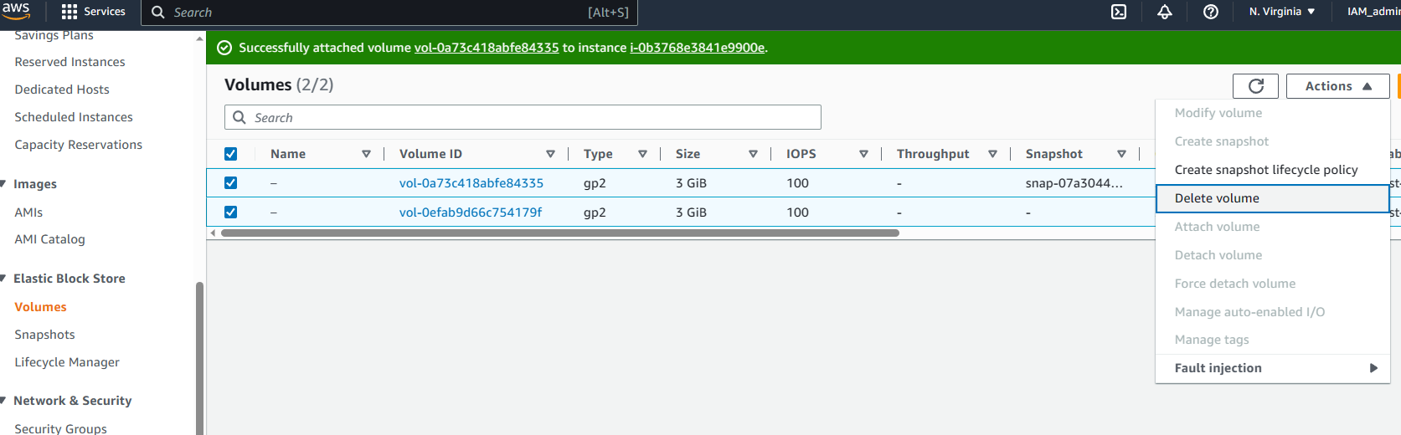

Specify “Delete**”** in the pop up and click on delete button

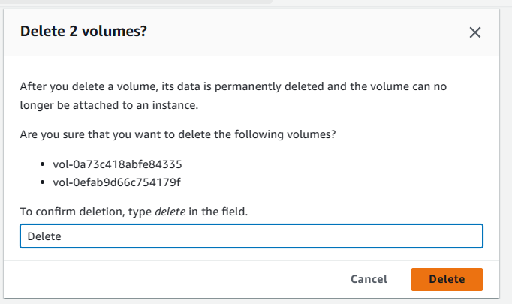

Select **snapshots** under **Elastic Block Store**, select the snapshot recently created, click on **actions** button and select **Delete Snapshots** button

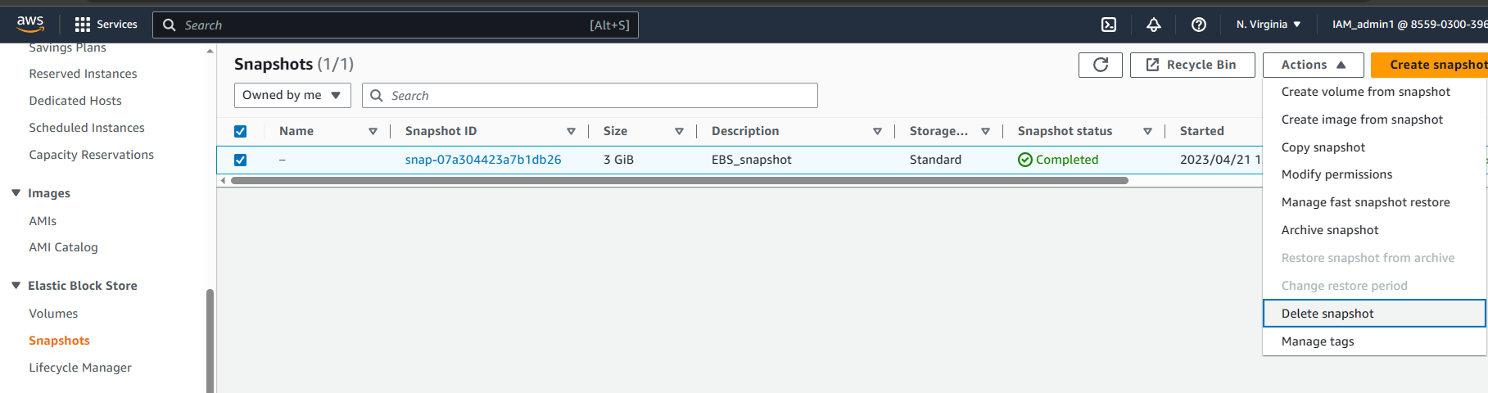

Click on **Delete** on the following pop up window

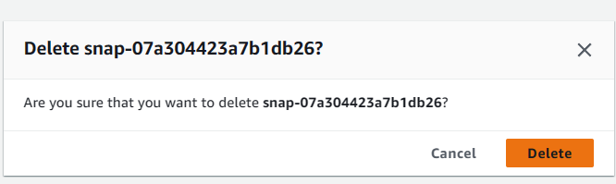

Visit the security groups page, select all the security group except the default security group and click on delete security group

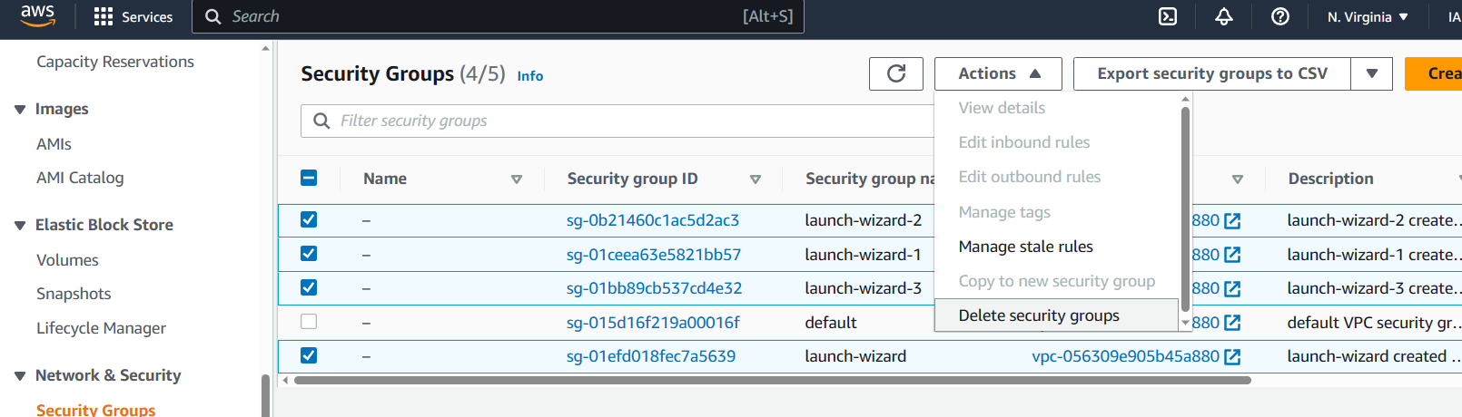

Specify delete and click on delete in the pop up window

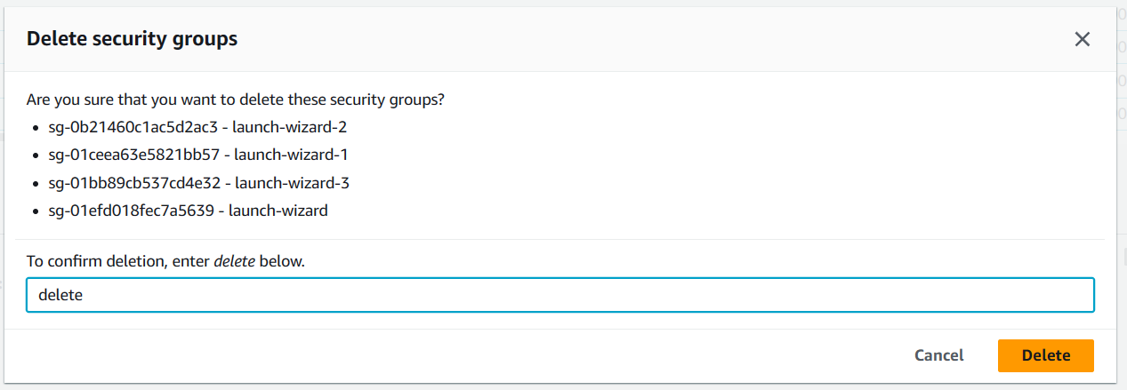

Root Instance can be detached from the instance while the instance is in stopped status

Newly created instance in running status

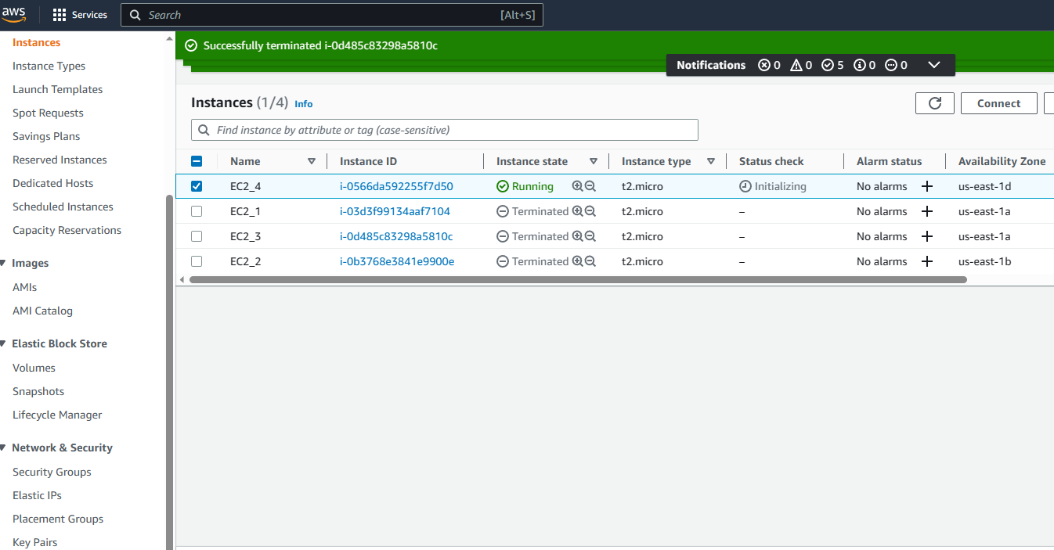

Newly generated root volume associated to the above instance

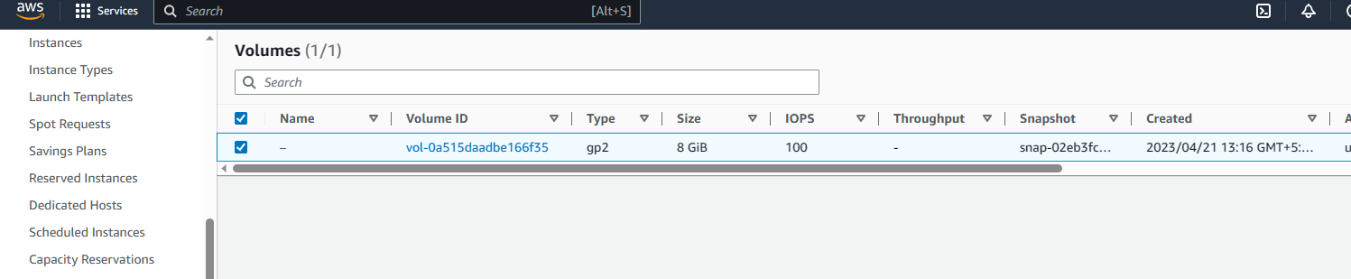

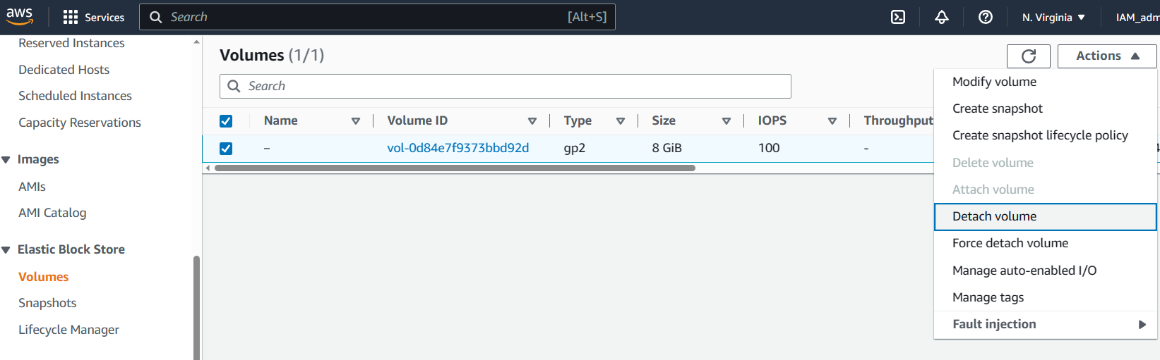

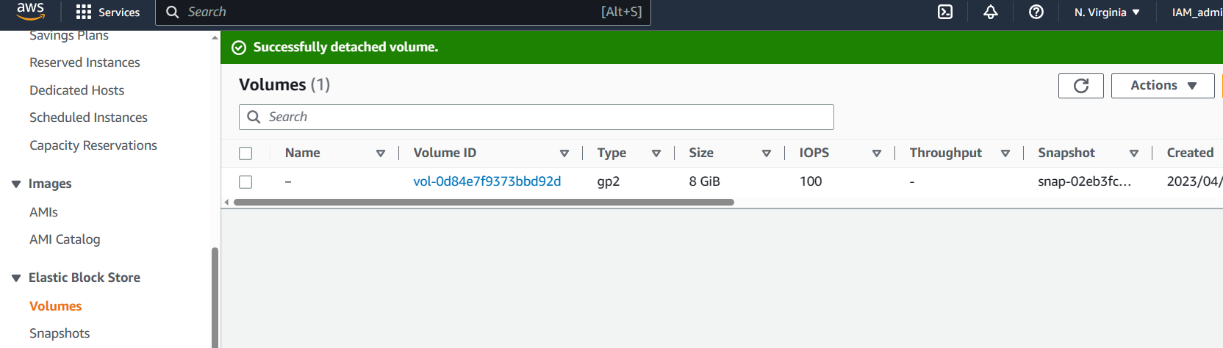

The root volume can be detached when the instance is in Stopped status